 

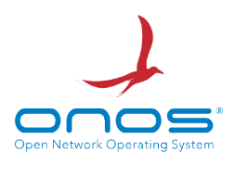

**Performance Benchmarking of POX, Ryu, HPE-VAN, OpenDaylight, and ONOS Controllers Based on QoS Parameters in Fat-Tree Networks**

**Prepared by   
ENG.KHALED ELSAYED MOTAWEA**

**For the month of September**

**2024**

**Table of Contents**

1. Introduction ................................................................................................................................ 3

1.1 Objective .............................................................................................................................................................. 3

1.2 Controllers Overview ........................................................................................................................................... 3

1.3 QoS Parameters .................................................................................................................................................... 5

1.4 Topology .............................................................................................................................................................. 6

2. Methodology .............................................................................................................................. 8

2.1 Network Setup ...................................................................................................................................................... 8

2.2 Controllers Setup ................................................................................................................................................ 12

2.3 Testing Procedure ............................................................................................................................................... 20

3. Experimentation ....................................................................................................................... 22

3.1 POX .................................................................................................................................................................... 22

3.2 RYU ................................................................................................................................................................... 31

3.3 HPE-VAN .......................................................................................................................................................... 37

3.4 OPENDAYLIGHT ............................................................................................................................................. 43

3.5 ONOS ................................................................................................................................................................. 48

4. Results ...................................................................................................................................... 54

4.1 Latency ............................................................................................................................................................... 54

4.2 Bandwidth .......................................................................................................................................................... 55

4.3 Throughput ......................................................................................................................................................... 57

4.4 Jitter and Packet Loss.......................................................................................................................................... 58

5. Discussion ................................................................................................................................ 61

5.1 Performance Insights .......................................................................................................................................... 61

5.2 Overall Performance comments ......................................................................................................................... 62

5.3 Real-World Implications .................................................................................................................................... 63

6. Conclusion ............................................................................................................................... 65

7. Missed Topics .......................................................................................................................... 67

8. References ................................................................................................................................ 70

9. Appendix .................................................................................................................................. 71

1. **Introduction**

**Objective**

The primary objective of this research is to conduct a comprehensive comparative analysis of several Software-Defined Networking (SDN) controllers (POX, Ryu, HPE-VAN, OpenDaylight, and ONOS). This study focuses on evaluating these controllers based on key Quality of Service (QoS) parameters, specifically bandwidth and throughput, latency, jitter, and packet loss. The experiments will be conducted within a fat tree topology to assess how effectively each controller manages network performance under varying conditions.

**Controllers Overview**

Software-Defined Networking (SDN) represents a significant shift in how networks are managed, providing centralized control and programmability through controllers. This study examines the following SDN controllers:

* **POX**: A lightweight, Python-based controller primarily used for educational purposes and small-scale experimental setups. It offers basic functionalities and is easy to use, making it a popular choice for initial SDN experiments.

- Supported OpenFlow Versions: 1.0

* **Ryu**: A component-based software defined networking framework, written in Python, that supports OpenFlow as well as other protocols. Ryu is known for its flexibility and is widely used in research due to its modular design and extensive documentation.

- Supported OpenFlow Versions: 1.0, 1.2, 1.3, 1.4

* **HPE-VAN (Hewlett Packard Enterprise Virtual Application Networks)** : A commercial-grade SDN controller designed for enterprise networks. It is known for its robust performance, scalability, and integration with HP's networking products.

- Supported OpenFlow Versions: 1.0, 1.3

* **OpenDaylight**: An open-source platform supported by the Linux Foundation, OpenDaylight is highly modular and scalable, making it suitable for large and complex networks. It is widely used in both academic research and industry.

- Supported OpenFlow Versions: 1.0, 1.3

* **ONOS (Open Network Operating System)** : A high-performance SDN controller optimized for service provider networks. ONOS is designed to provide scalability, availability, and performance, making it ideal for large-scale deployments.

- Supported OpenFlow Versions: 1.0, 1.3

These controllers differ in terms of architecture, capabilities, and intended use cases, which provides a rich basis for comparison in this study.

Here's a comparison table for the SDN controllers (POX, Ryu, HPE-VAN, OpenDaylight, and ONOS) based on programming language, supported OpenFlow versions, and other key capabilities:

|  |  |  |  |  |  |  |
| --- | --- | --- | --- | --- | --- | --- |
| Feature | Pox | Ryu | HPE-VAN | | OpenDayLight | ONOS |
| Programming Languages | Python | Python | java | | java | java |
| Supported OpenFlow Versions | 1.0 | 1.0, 1.2, 1.3, 1.4 | 1.0,1.3 | | 1.0,1.3 | 1.0,1.3 |
| Architecture | Monolithic | Modular | Centralized | Modular, Highly Scalable | | Distributed, Highly Scalable |
| Ease of Use | Easy (Good for Learning & Small Projects) | Easy to Moderate (Flexible & Well-Documented) | Moderate to Difficult (Enterprise-Grade) | | Moderate to Difficult (Enterprise & Research) | Moderate to Difficult (Service Provider Networks) |
| Scalability | Low | Medium | High | | High | Very High |
| Extensibility | Limited (Mostly for Small-Scale Applications) | High (Supports Multiple Protocols and Custom Apps) | Medium (Customizable for Enterprises) | | Very High (Supports Plugins & Custom Apps) | Very High (Designed for Large-Scale Deployments) |
| Community Support | Small (Primarily Educational Use) | Large (Active in Research Community) | Medium (Supported by HPE) | | Large (Backed by Linux Foundation & Industry) | Large (Backed by ON.Lab & Industry) |
| Use Cases | Educational, Experimental | Research, Prototyping, Production | Enterprise Networks | | Research, Enterprise, Carrier-Grade Networks | Service Providers, Carrier-Grade Networks |
| Integration | Basic (Few External Integrations) | Moderate (Supports Various Networking Protocols) | Extensive (Works with HP Networking Products) | | Extensive (Integrates with Various Technologies) | Extensive (Focus on Integration with Carrier Services) |
| Security Features | Basic | Moderate (Depends on Implementation) | Advanced (Enterprise-Grade Security) | | Advanced (Enterprise & Carrier-Grade Security) | Advanced (Focus on Carrier-Grade Security) |

**QoS Parameters**

Quality of Service (QoS) is critical in networking, as it ensures the reliable and efficient delivery of data across a network. In this research, the following QoS parameters will be the focal points of evaluation:

* **Bandwidth and Throughput**: Bandwidth refers to the maximum data transfer capacity of a network, while throughput is the actual rate at which data is successfully transmitted. Both metrics are essential for assessing the efficiency of a network.
* **Latency**: Latency measures the time taken for a packet of data to travel from the source to the destination. Lower latency is critical for real-time applications such as video conferencing and online gaming.
* **Jitter**: Jitter refers to the variation in packet arrival times, which can affect the quality of streaming services, VoIP calls, and other time-sensitive communications.
* **Packet Loss**: Packet loss occurs when one or more packets of data fail to reach their destination. High packet loss can significantly degrade network performance and user experience.

These QoS parameters will provide a comprehensive view of how each SDN controller performs under different network conditions.

**Topology**

The fat tree topology, a widely recognized and used network structure, will serve as the testing environment for this study. This topology is particularly suitable for data centers and large-scale networks due to its ability to balance load and provide redundancy. The hierarchical structure of the fat tree topology mirrors real-world network scenarios, making it an ideal choice for evaluating SDN controllers in terms of scalability, fault tolerance, and overall performance.

The choice of a fat tree topology is motivated by its ability to emulate the complex and dynamic nature of modern network environments. This topology will allow us to assess how each SDN controller handles the challenges of maintaining QoS across multiple layers of network switches and hosts.

Here is a screenshot of the topo with GNS3 (presents the Topology clearly and accurately) that I worked on it:

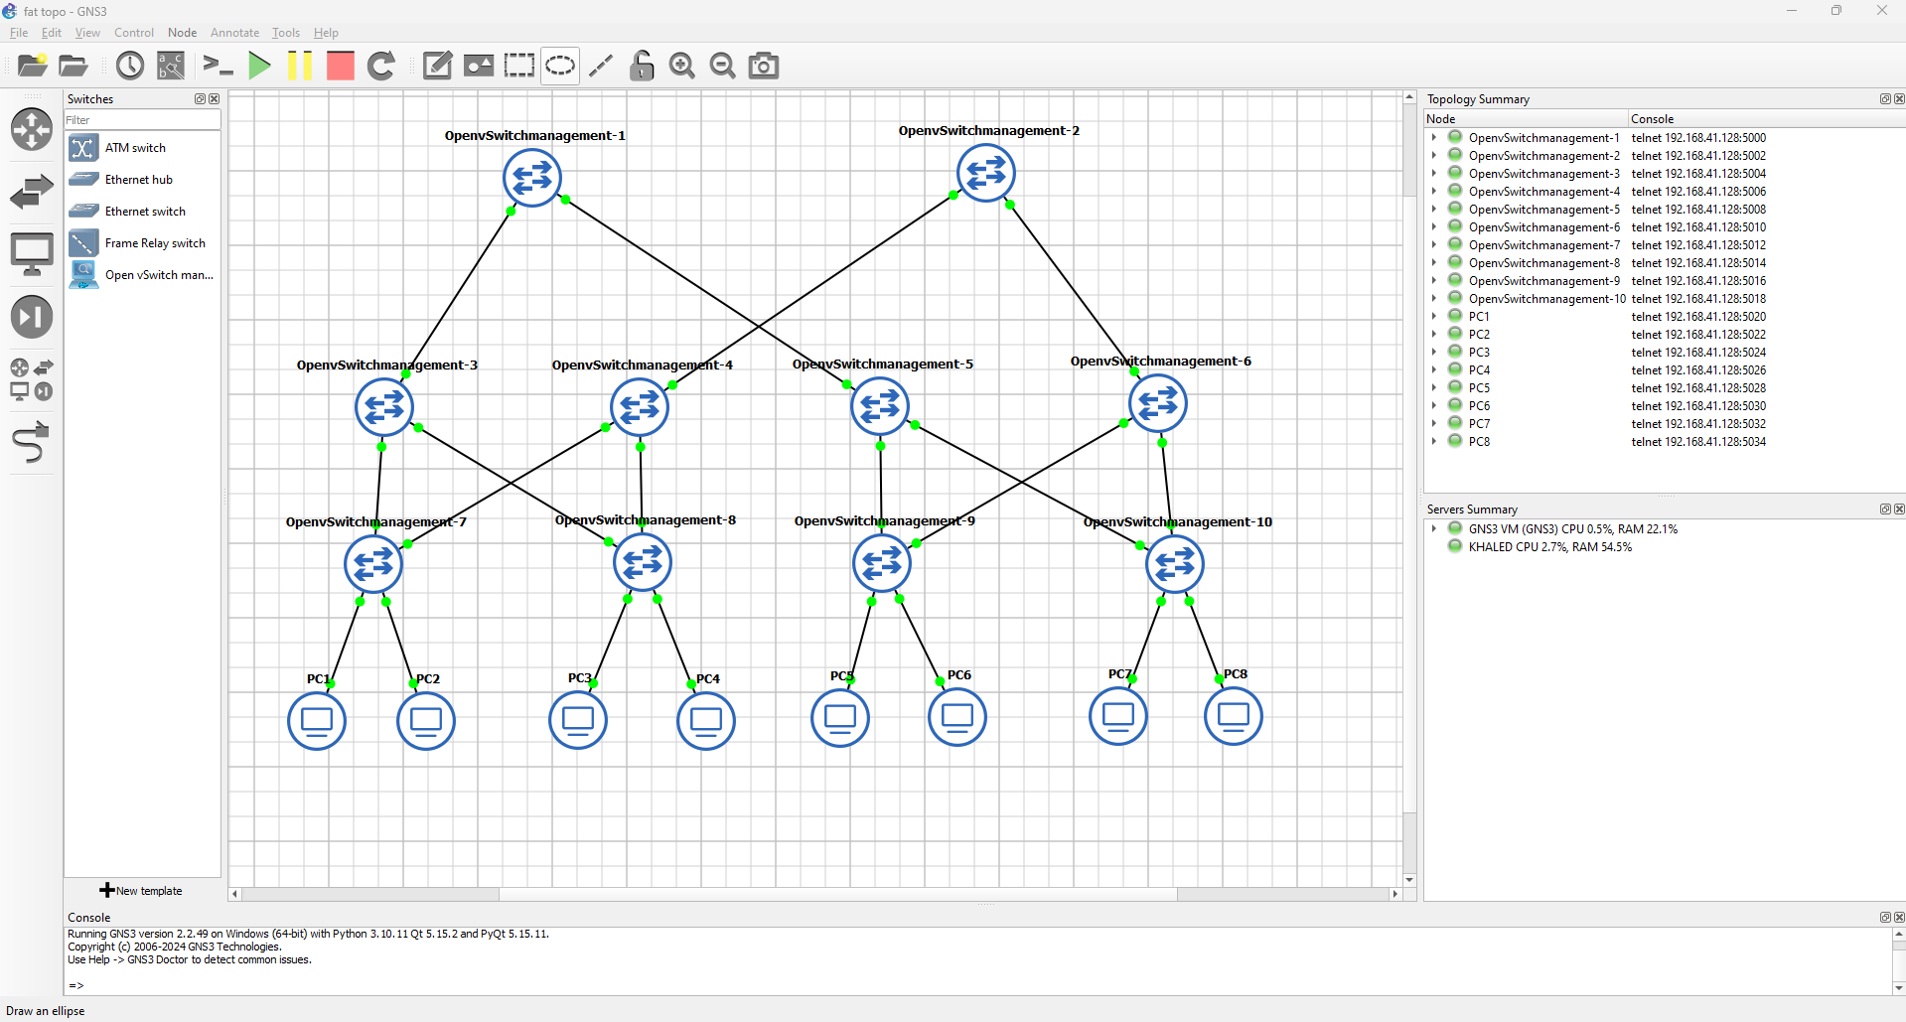

GNS3  is a versatile network simulation tool that supports the integration of Open vSwitch and Docker, enabling the creation of complex and realistic network topologies. Open vSwitch provides advanced switching capabilities within virtualized environments, while Docker allows for the deployment of lightweight, scalable containers to emulate network devices. Together, they allow GNS3 to simulate SDN environments effectively, offering flexibility and scalability for testing and development without the need for physical hardware. This makes GNS3 ideal for both learning and professional network design.

But here in my research I implemented the topology using Mininet emulator   
Mininet  is a powerful network emulator that enables the creation of virtual networks for testing and development, particularly in SDN environments. It provides a realistic simulation of network devices like switches, hosts, and controllers, using lightweight virtual machines. With built-in support for Open vSwitch, Mininet allows users to test SDN controllers and network applications in a controlled environment. Its flexibility and ease of use make it an essential tool for experimenting with network protocols, topologies, and SDN concepts, bridging the gap between theoretical learning and real-world application.

**2. Methodology**

* **Network Setup:**

The network setup is centered around a custom Python script designed to create a fat tree topology within Mininet. This topology is widely used in data center networks due to its scalability and efficient traffic distribution capabilities. The script defines multiple layers of switches (2-core, 4-aggregation, and 4-edge) which are interconnected to simulate a hierarchical network structure. Hosts are connected to the edge switches (8 hosts), representing endpoints in the network. This arrangement allows for comprehensive testing of QoS parameters, such as bandwidth, latency, jitter, and packet loss, under realistic conditions, making it an ideal environment for comparing the performance of various SDN controllers.

here is the py script that automate the topo using mininet libraries:

from mininet.topo import Topo

from mininet.net import Mininet

from mininet.node import OVSSwitch, RemoteController

from mininet.cli import CLI

from mininet.log import setLogLevel

class FatTreeTopo(Topo):

def build(self):

# Create hosts

h1 = self.addHost('h1')

h2 = self.addHost('h2')

h3 = self.addHost('h3')

h4 = self.addHost('h4')

h5 = self.addHost('h5')

h6 = self.addHost('h6')

h7 = self.addHost('h7')

h8 = self.addHost('h8')

# Create switches

s1 = self.addSwitch('s1')

s2 = self.addSwitch('s2')

s3 = self.addSwitch('s3')

s4 = self.addSwitch('s4')

s5 = self.addSwitch('s5')

s6 = self.addSwitch('s6')

s7 = self.addSwitch('s7')

s8 = self.addSwitch('s8')

s9 = self.addSwitch('s9')

s10 = self.addSwitch('s10')

# Add links between hosts and switches

self.addLink(h1, s7)

self.addLink(h2, s7)

self.addLink(h3, s8)

self.addLink(h4, s8)

self.addLink(h5, s9)

self.addLink(h6, s9)

self.addLink(h7, s10)

self.addLink(h8, s10)

# Add links between lower layer switches and middle layer switches

self.addLink(s7, s3)

self.addLink(s4, s8)

self.addLink(s9, s5)

self.addLink(s6, s10)

#____________

self.addLink(s3, s8)

self.addLink(s4, s7)

self.addLink(s6, s9)

self.addLink(s5, s10)

#__________

# Add links between middle layer switches and upper layer switches

self.addLink(s3, s1)

self.addLink(s5, s1)

self.addLink(s4, s2)

self.addLink(s6, s2)

#self.addLink(s1, s2)

# Register the custom topology

topos = {'custom': (lambda: FatTreeTopo())}

**Explanation of the Code**

The provided Python code is a script for creating a custom fat tree topology in Mininet, a network emulator used for testing and developing network configurations, especially in SDN (Software-Defined Networking) environments.

1. Importing Required Modules:

- The script begins by importing necessary modules from Mininet:

- `Topo`: Base class for creating custom network topologies.

- `Mininet`: Used to create and manage the virtual network.

- `OVSSwitch` and `RemoteController`: Represent the switch and controller types.

- `CLI`: Provides an interactive command-line interface to interact with the network.

- `setLogLevel`: Allows setting the logging level for debugging purposes.

2. Creating the Fat Tree Topology Class:

- The `FatTreeTopo` class inherits from `Topo` and defines the network topology.

- `build(self)`: This method is where the actual topology is defined

3. Defining Hosts:

- Eight hosts (`h1` to `h8`) are created using the `addHost` method. These represent the end devices in the network.

4. Defining Switches:

- Ten switches (`s1` to `s10`) are created using the `addSwitch` method. These switches form the different layers of the fat tree topology: core, aggregation, and edge.

5. Connecting Hosts to Edge Switches:

- Hosts are connected to edge switches using the `addLink` method:

- `h1` and `h2` connect to `s7`.

- `h3` and `h4` connect to `s8`.

- `h5` and `h6` connect to `s9`.

- `h7` and `h8` connect to `s10`.

6. Connecting Edge to Aggregation Switches:

- The script connects the edge switches to aggregation switches:

- `s7` connects to `s3`, and `s8` connects to `s4`.

- `s9` connects to `s5`, and `s10` connects to `s6`.

- Additional links are established between these switches to create redundancy and improve network performance.

7. Connecting Aggregation to Core Switches:

- Finally, the aggregation switches are connected to the core switches:

- `s3` and `s5` connect to `s1`, representing one core switch.

- `s4` and `s6` connect to `s2`, representing another core switch.

8. Registering the Topology:

- The custom topology is registered in the `topos` dictionary with the key `'custom'`, allowing it to be instantiated later when running Mininet.

This script effectively sets up a fat tree topology, a hierarchical network structure commonly used in data centers. The fat tree design enables efficient routing and high network throughput, making it an ideal choice for testing SDN controllers and QoS parameters.

Here is a sample of how I run the topo using the script

for example: when running the topo with pox controller I need to specify these arguments:  
- the type of the network (-- topo custom) and give it the py script of the topo.

- the controller state (remote) and the ip and the working port of it.

- the types of the working switches(ovs) and the version of the OpenFlow protocol.

Ex: *$sudo mn --custom qos_topo.py --topo custom --controller=remote,ip=192.168.1.3 --switch=ovs,protocols=OpenFlow10*

Of course, these arguments will change with each controller.

And here is the topology with miniedit simulator that exists in mininet examples:

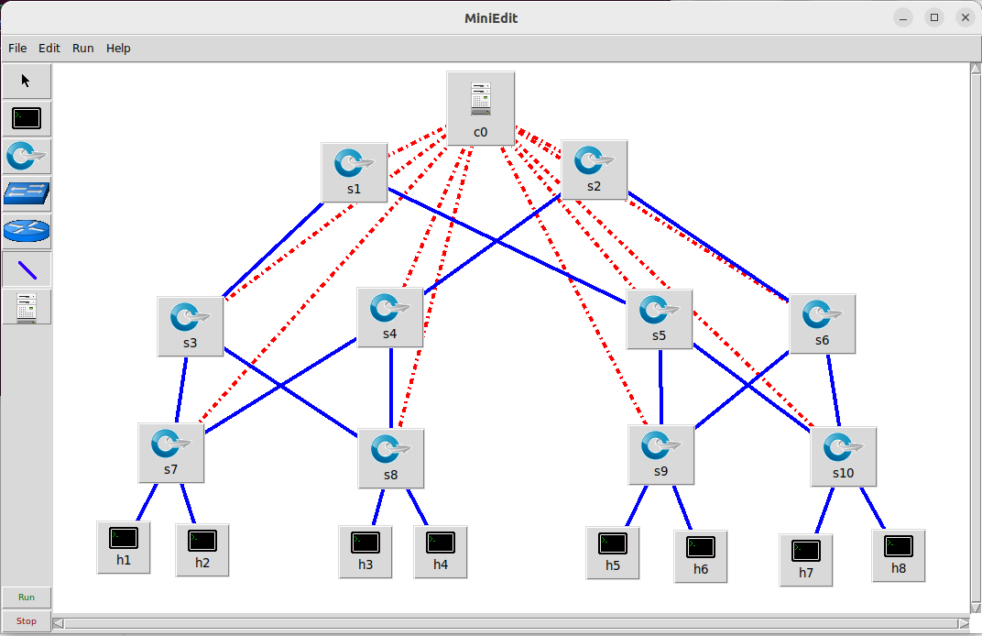

* **Controllers Setup**

I will demonstrate how I installed all these five controllers’ step by step. Of course, I walked with the installation guide from the official website of each controller and I for sure I faced many errors with the installation and the most common error was in the type of the operating version of the used programing language in each controller.

**1) POX**

1. Python 2.7.x should be installed on my system, as POX is primarily compatible with Python 2.x. So, I installed it and made it the working version.
2. Update the machine and install git by running the following command in the terminal  
   *$sudo apt-get update*

*$sudo apt-get install git*

1. *Clone the POX source code from its GitHub repository:  
   $ git clone* [*https://github.com/noxrepo/pox.git*](https://github.com/noxrepo/pox.git)This will download the POX codebase into a directory named pox.
2. Navigate to the POX Directory:  
   *$ cd pox*
3. Run POX: To start the POX controller, run the following command:  
   *$ ./pox.py openflow.of_01 –port=6633 forwarding.l2_learning*This command starts the POX controller with the l2_learning module, which is a basic learning switch application, It was up and working perfectly

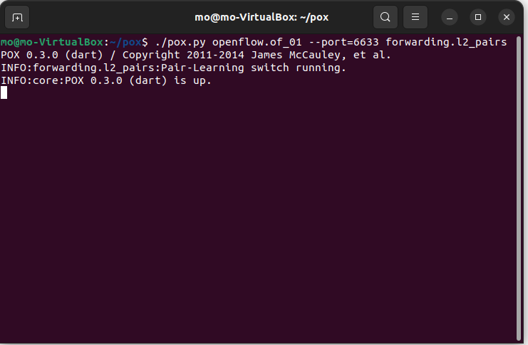

.

**2) RYU**

1. Python 3.7 is required, as Ryu is compatible with Python 3.
2. So, to save time switching between one Python version and another, I downloaded RYU Machine ready from this link (https://drive.google.com/file/d/1_5PQWBsQcVnxtzwhUMzP-w2mR9MZrG6S/view?usp=sharing) and it works on the required version and works efficiently.
3. Run the following command to make sure that it works good  
   *$ ryu-manager --verbose --observe-links ryu.app.simple_switch_13*

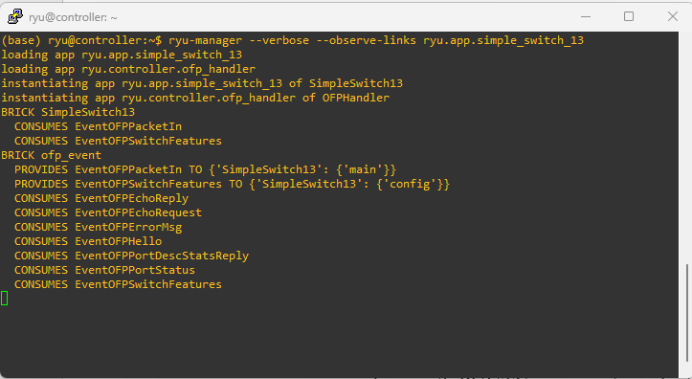It should be work as follows (I prefer to connect the ryu machine with PUUTY program to make the operation more flexible):

**3) HPE-VAN**

1. HPE VAN SDN Controller can be installed on a Linux-based system, with CentOS or Red Hat Enterprise Linux being recommended. So, I downloaded the ova machine already ready, and the controller installed on it (hpe-van 2.7.18) from this link (https://drive.google.com/file/d/1dFlznsbXnkg5s06uIC8aXmz4DzZ_4Je8/view?usp=drive_link). And for sure it works perfectly.
2. Java Runtime Environment: Java 1.8 or higher which is already installed in the machine.

Now keep the machine running and go to the web browser and run the following url  
<https://x.x.x.x:8443>  
It will ask for authentication of course   
username : sdn  
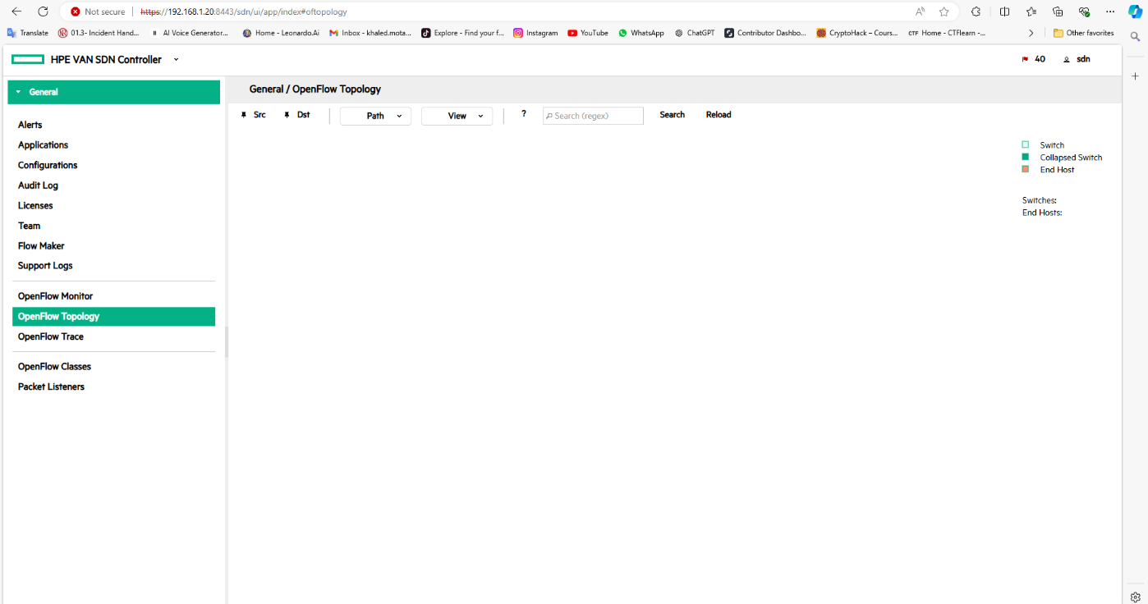password : skyline

**4) OpenDayLight**

1. On the same ubuntu machine that have the POX controller installed in I installed the ODL controller (0.6.2 Carbon) as follows.
2. First update the ubuntu by running this command in the terminal  
   *$sudo apt update*  
   second install the working version of java that the controller work with (java 1.8) by running this command in the terminal  
   *$ apt-get install maven git openjdk-8-jre openjdk-8-jdk unzip*
3. Make the java version 1.8 as the working version in the java_home by running the following command   
   *$ export JAVA_HOME=/usr/lib/jvm/java-1.8.0-openjdk-amd64*
4. Now download the ODL from this following link using the *wget* tool by running the following command in the terminal  
   *$wget* [*https://nexus.opendaylight.org/content/repositories/public/org/opendaylight/integration/distribution-karaf/0.6.2-Carbon/distribution-karaf-0.6.2-Carbon.tar.gz*](https://nexus.opendaylight.org/content/repositories/public/org/opendaylight/integration/distribution-karaf/0.6.2-Carbon/distribution-karaf-0.6.2-Carbon.tar.gz)
5. Unzip the .tar file as follows  
   *$sudo tar -zvxf distribution-karaf-0.6.2-Carbon*
6. Now go to this directory to run the ODL controller by executing the ./karaf file but first check the working java_home version 1.8 as I said before.  
   *distribution-karaf-0.6.2-Carbon /bin$./karaf*
7. After that install these services in the console of the odl controller to make it work as good as possible   
   *>feature:install odl-restconf*

*>feature:install odl-l2switch-switch*

*>feature:install odl-mdsal-apidocs*

*>feature:install odl-dlux-core*

*>feature:install odl-dluxapps-topology*

*>feature:install odl-dluxapps-nodes*

1. *Now you can easily access the gui of the controller using the following url*[*http://x.x.x.x:8181/index.html*](http://x.x.x.x:8181/index.html)

It will ask for authentication of course   
username : admin  
password : admin

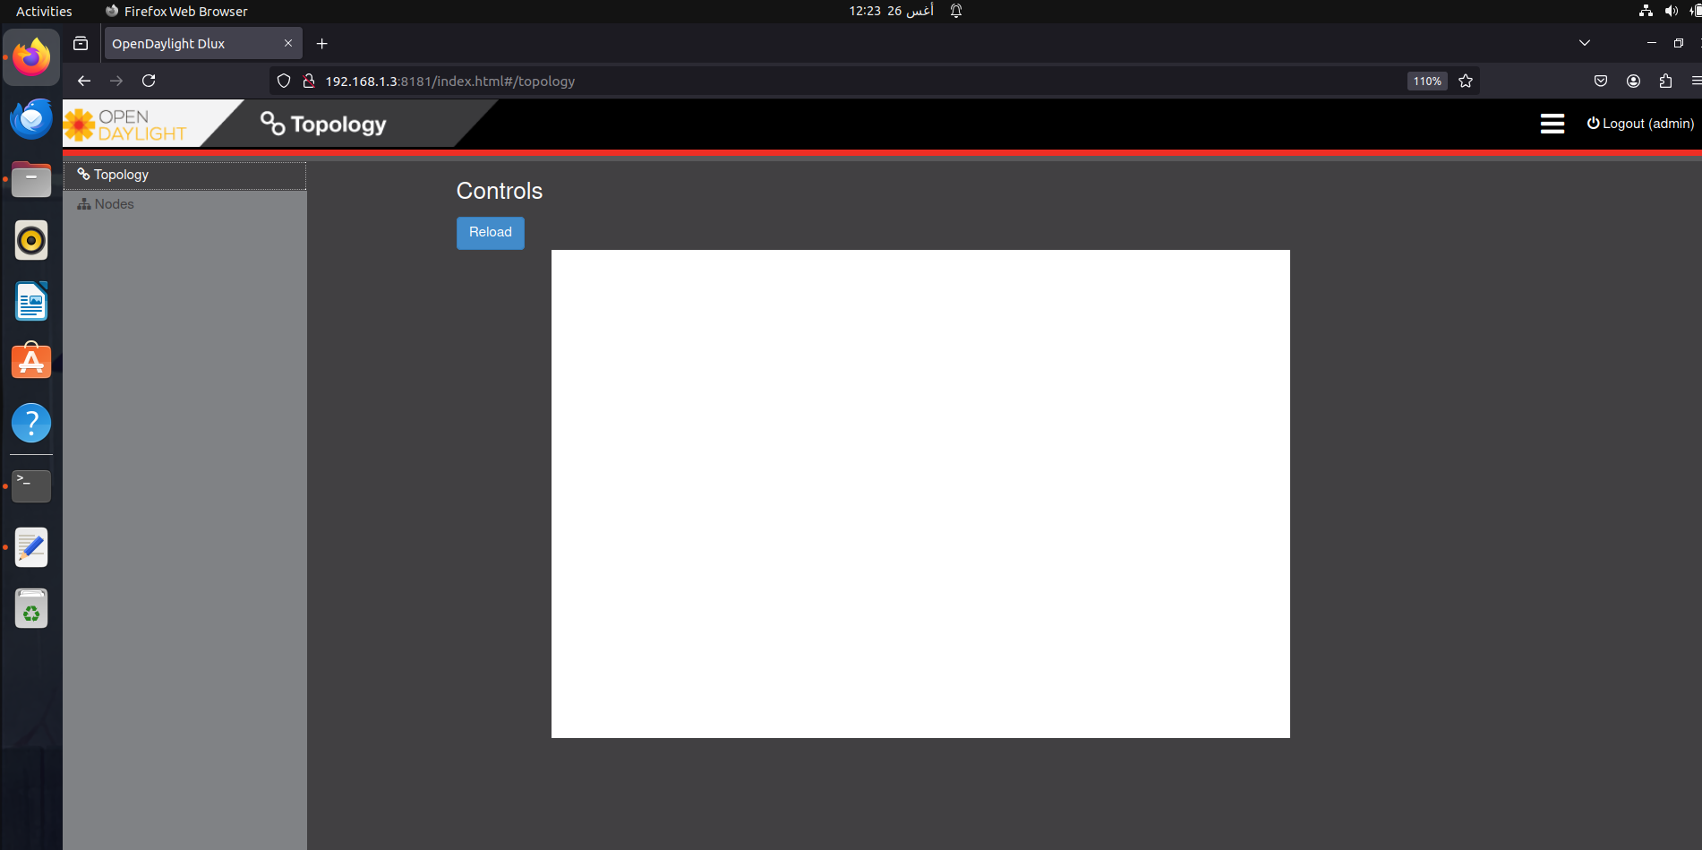

**5) ONOS**

1. On the same ubuntu machine that have mininet and pox and opendaylight installed in with same version of jave (1.8) the onos will work with.So check the working version of java before the installation of onos.
2. Open terminal and download this vestion of onos (Quail 2.0.0) by running the following command   
   *$wget* [*https://repo1.maven.org/maven2/org/onosproject/onos-releases/2.0.0/onos-2.0.0.tar.gz*](https://repo1.maven.org/maven2/org/onosproject/onos-releases/2.0.0/onos-2.0.0.tar.gz)
3. Then unzip the tar file as follows   
   *$ tar -zxvf onos-2.0.0.tar.gz*
4. Copy files in folder to /opt/onos   
   *$ sudo mkdir /opt/onos*   
   *$ sudo cp -r onos-2.0.0/* /opt/onos*
5. Run onos services  *$ cd /opt/onos/bin  
   $ sudo /opt/onos/bin/onos-service start*
6. Open another terminal Add configuration to ~/.ssh/config

*$ mkdir ~/.ssh*

*$ vim ~/.ssh/config*

*HostKeyAlgorithms +ssh-rsa   
PubkeyAcceptedKeyTypes +ssh-rsa  
-> save and out by typing :wq*

1. Connect to onos cli and activate application   
   *$ /opt/onos/bin/onos -l onos*

password: rocks

1. Activate these services   
   *onos@root$ app activate org.onosproject.pipelines.basic onos@root$ app activate org.onosproject.fwd   
   onos@root$ app activate org.onosproject.openflow*
2. Login GUI Open browser and type   
   localhost:8181/onos/ui  
   username: onos   
   password: rocks
3. Note: Try to make the ip of ubuntu static this will be better when connecting to the mininet topology every time with every controller.

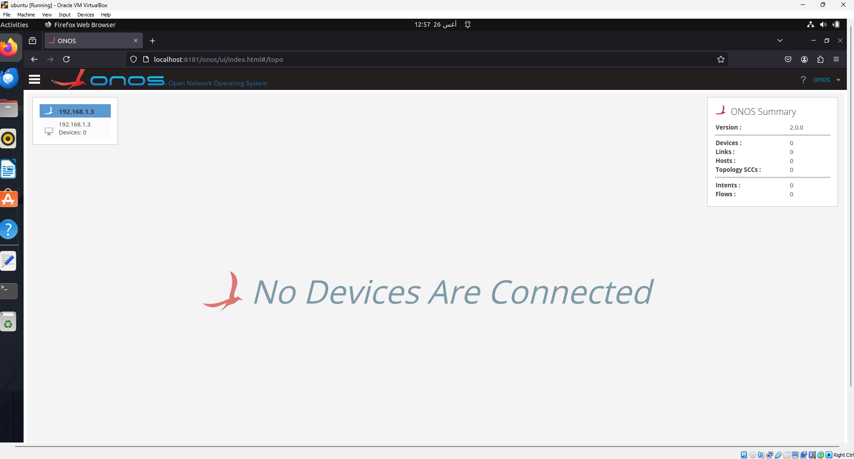

These are the steps to install all controllers step by step as we have seen.  
Note: make sure of the working version of programming language on each controller as I said to Avoid errors.

* **Testing Procedure**

**QoS Testing Tools:**

To evaluate the QoS parameters across the different SDN controllers, a set of widely used network testing tools will be employed. These tools include:

- `iperf`: A tool for measuring bandwidth and network throughput.

- `ping`: A basic utility to measure round-trip time (RTT), providing insight into network latency.

- `tcpdump and Wireshark`: A packet analyzer used to capture and analyze network traffic, which can be helpful for understanding packet loss and other network behaviors.

**Testing Steps:**

The following steps outline how each QoS parameter will be tested across the controllers:

**1. Bandwidth and Throughput:**

- Tool: `iperf`

- Procedure:

* Run `iperf` in client-server mode between two hosts in the network.
* Measure the throughput over a specified period.
* Record and compare the results across the different controllers to see how they manage network bandwidth.

**2. Latency:**

- Tool: `ping`

- Procedure:

* Use the `ping` command to send ICMP echo requests from one host to another.
* Measure the round-trip time (RTT) for the packets.
* Analyze the latency data to determine how each controller affects the time taken for data to travel between hosts.

**3. Jitter:**

- Tool: `iperf` (in UDP mode)

- Procedure:

* Run `iperf` in UDP mode to send a stream of packets between two hosts.
* Measure the variation in packet arrival time (jitter).
* Compare jitter levels to assess the stability and performance of each controller under different conditions.

**4. Packet Loss:**

- Tool: `iperf` (in UDP mode)

- Procedure:

* Use `iperf` to generate UDP traffic between two hosts.
* Measure the number of packets lost during transmission.
* The packet loss percentage will be calculated to determine how effectively each controller manages network reliability.

These testing steps will be repeated for each controller (POX, Ryu, HPE-VAN, OpenDaylight, ONOS) in the fat tree topology to gather data and compare their performance in managing network resources and maintaining QoS.

**3. Experimentation**

Running Tests:

In this section I will do the qos tests for all controllers and all of them will follow the same sequence so let, s start with pox.

**POX**

1. Initiate the pox controller to listen for the incoming topology connection by opening a separate terminal window, one for the pox controller and the other for the mininet topology.
2. As I mentioned before I will run the fat topo using a python script with help of mininet libraries (because the topo is customized it should be created by a py script not a command), and the python file named Fat_Tree_Topo.py.
3. 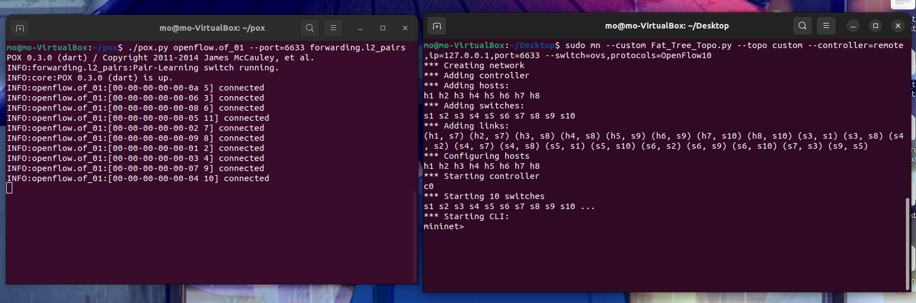Up the topo and the controller as follows  
      
   as we see the pox see the ovs and connected with it,also the network up with default ip , port and the appropriate version of the OpenFlow protocol and –mac to make the addresses of the switches readable easily , So let’s now do our qos tests.
4. When trying to do the ping test to see the latency the ping not works between h1 and h8 as follows   
   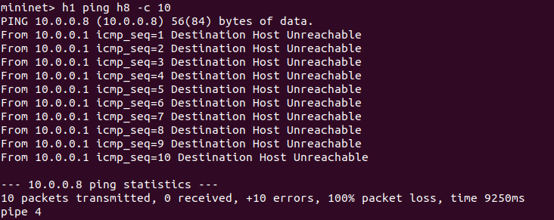  
   I run the links command to see if the links are stable or not   
   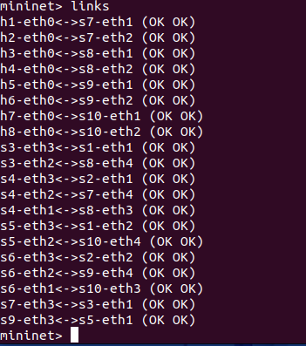

it seems everything is okey with links so I tried to pingall to see if any host can reach any other host and it not works as follows   
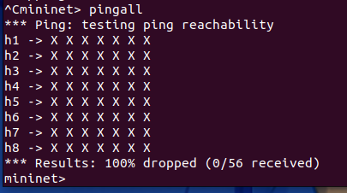

The challenge with the POX controller likely stems from its inherent limitations, particularly in managing multi-path topologies like the fat tree topology. POX's default forwarding applications, such as `l2_learning`, are designed with simplicity in mind and may not be equipped to efficiently handle traffic across multiple paths or navigate more complex network topologies.

note: I can implement routing algorithm here or static flows to make all the network reachable but, in this research, the main goal is comparing between these controllers in terms of QoS and this limits the pox controller because it cannot handle the forwarding of the traffic in fat trees topologies.  
It could be work if I reduced the links and reduces the multipath links and I tried it and it works but not efficient with qos.

*So here is the problem and the solution:*  
The issue you encountered was caused by loops in the fat tree topology, which arose due to the use of multipath routing. These loops can lead to broadcast storms and prevent proper packet forwarding, particularly when using a basic controller like POX. The solution was to enable the Spanning Tree Protocol (STP) with the POX controller, which effectively eliminated the loops by blocking redundant paths. Once STP was activated, the network stabilized, and packet forwarding, including ping between hosts, worked smoothly and efficiently.  
  
here is how I did it with pox console   
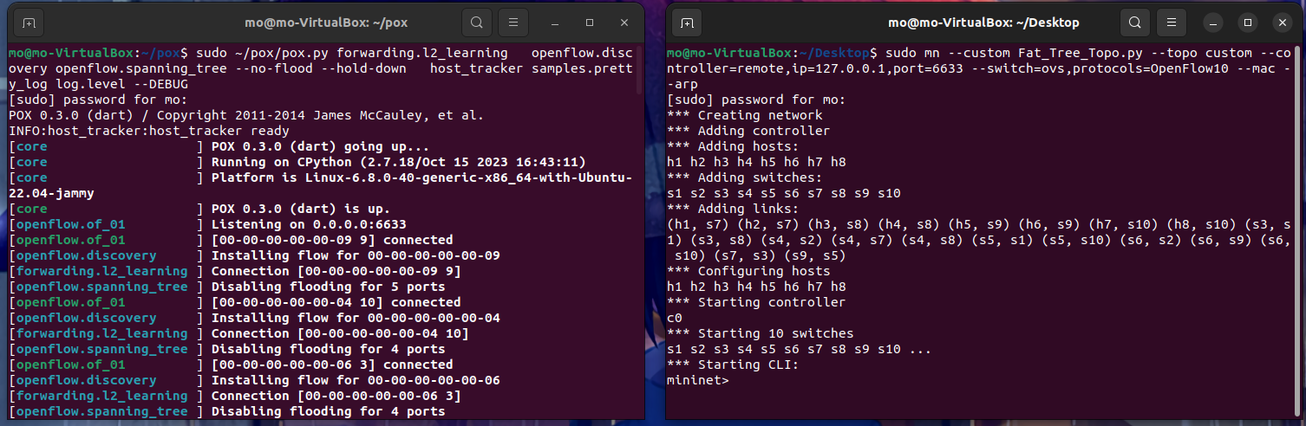

This command starts the POX controller with several key modules that enable specific functionalities:

1. `forwarding.l2_learning`: This module enables simple Layer 2 (L2) learning, where the controller learns the MAC addresses of hosts and installs flow rules to forward packets based on these addresses.

2. `openflow.discovery`: This module allows the POX controller to discover the network topology by listening to OpenFlow events such as link state changes.

3. `openflow.spanning_tree`: This module implements the Spanning Tree Protocol (STP), which prevents network loops by disabling redundant paths in the network.

4. `--no-flood --hold-down`: These options are passed to the Spanning Tree Protocol module. `--no-flood` prevents unnecessary packet flooding, and `--hold-down` delays the activation of new links, helping stabilize the network after topology changes.

5. `host_tracker`: This module tracks the location of hosts in the network, which is useful for handling host mobility and ensuring accurate forwarding.

6. `samples.pretty_log`: This module formats log messages in a more readable way, making it easier to monitor the controller's activity.

7. `log.level --DEBUG`: This sets the logging level to `DEBUG`, providing detailed output for troubleshooting and analyzing the controller’s behavior.

In summary, this command configures the POX controller to manage a network using L2 learning, topology discovery, and loop prevention, while providing detailed logging for monitoring and debugging.

1. 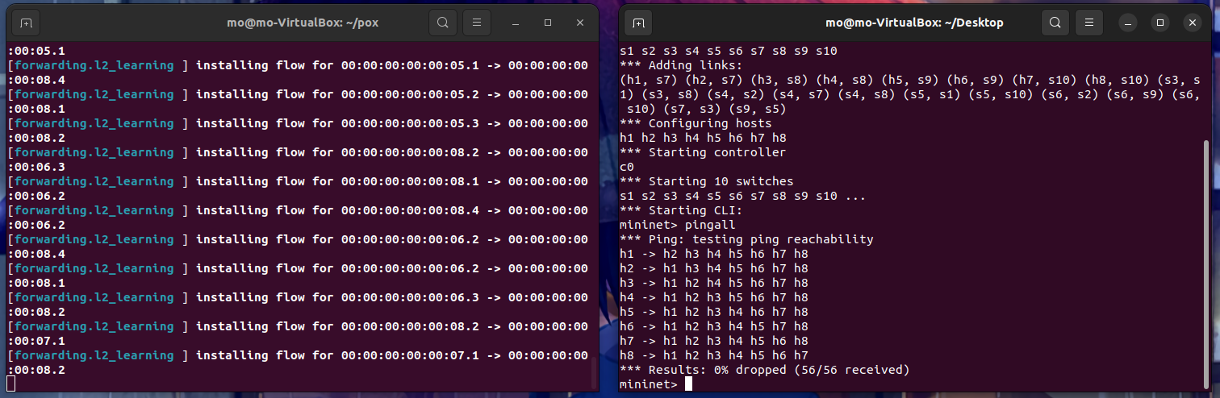Now when I pingall again with the updates it works .
2. I will not say how the spanning tree works and what is it, s logic but it of course updated every amount of time, or any changes happens in the network it updated in the network as follows:

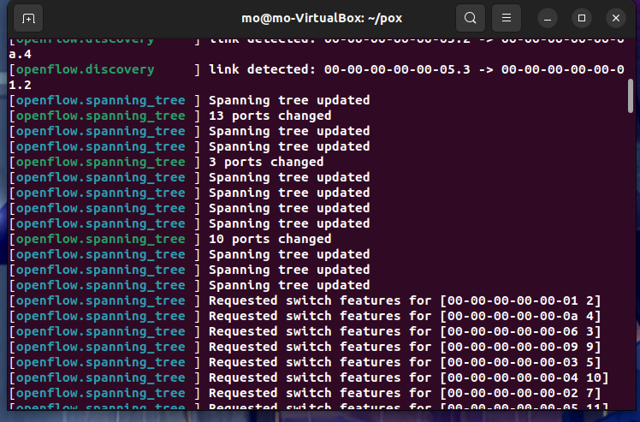

1. 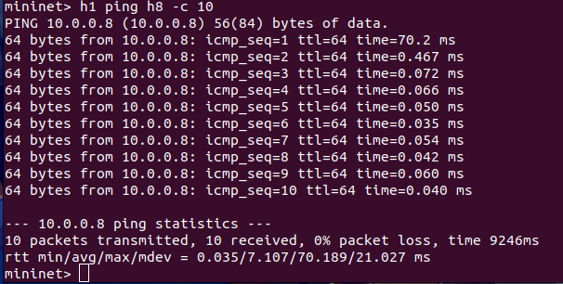So, after the problem was solved let’s do our QOS tests starting with latency (the latency test will be pinging from h1 to h8 in all scenarios with all controllers):

And here is the graph representation of the ping

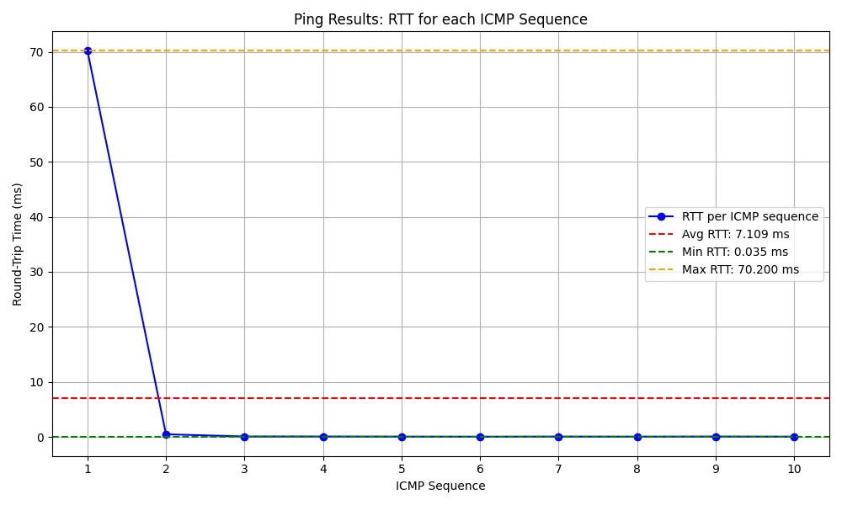

1. Now let’s test on the bandwidth with Iperf tool as follows  
   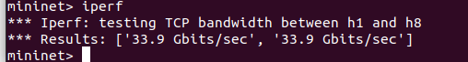

The first speed is the upload and the second is the download

1. Now let, s test on the throughput also with iperf (server/client communication)

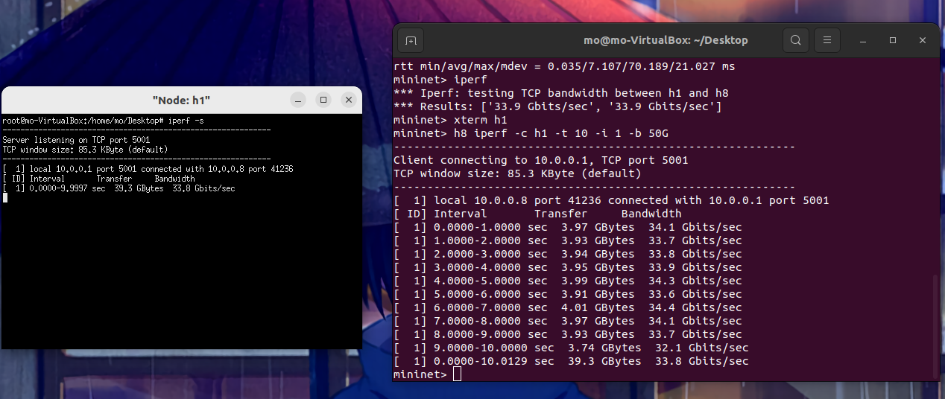  
  
note: the throughput is the is the actual rate at which data is successfully transmitted.  
So, I make the bandwidth limit 50Gb/s to see the actual rate transmission. here is the graph representation of the throughput values  
  
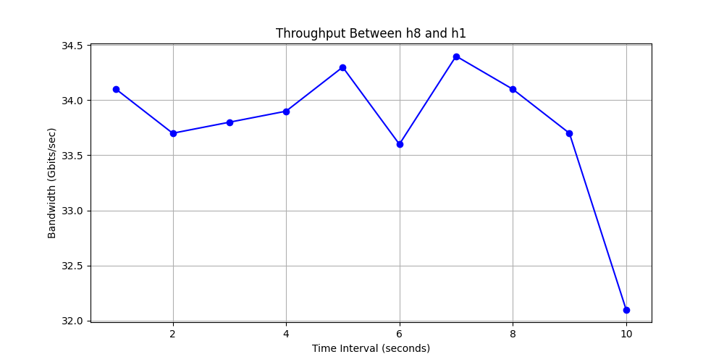

1. Now let’s test the jitter and packet loss also with iperf

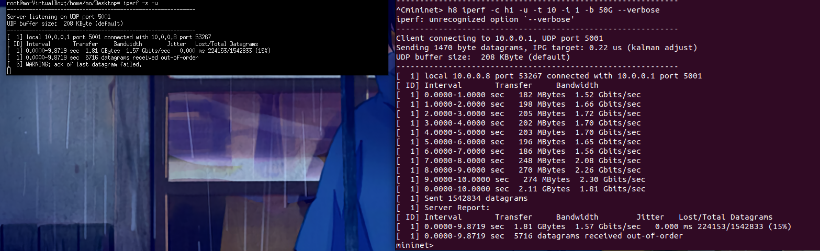

And here the graph representation of the test   
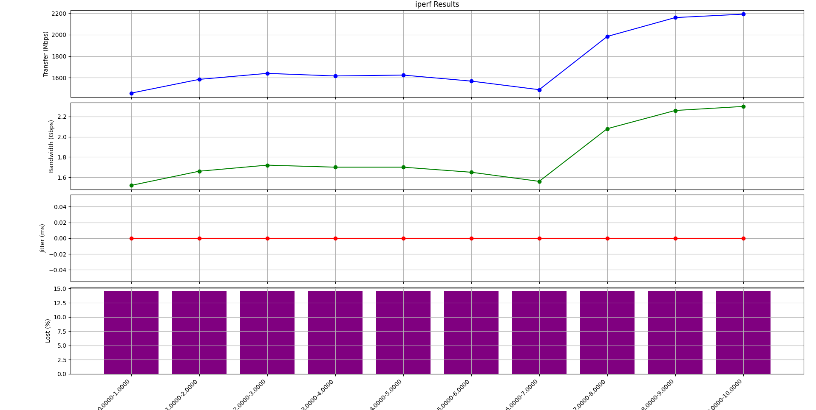  
note: of course I can monitor and capture all the traffic in the network as follows for example the last test of jitter and packet loss:  
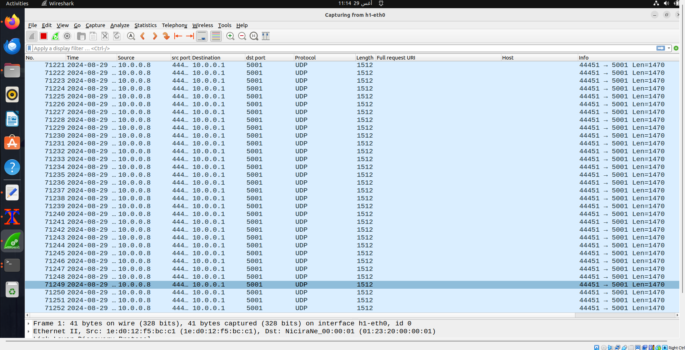  
but this will tack much time .So I will focus on the qos results only .  
note: pox has a gui application called gephi and can represent the topo but I did not install it to save time.

* **RYU**

1. 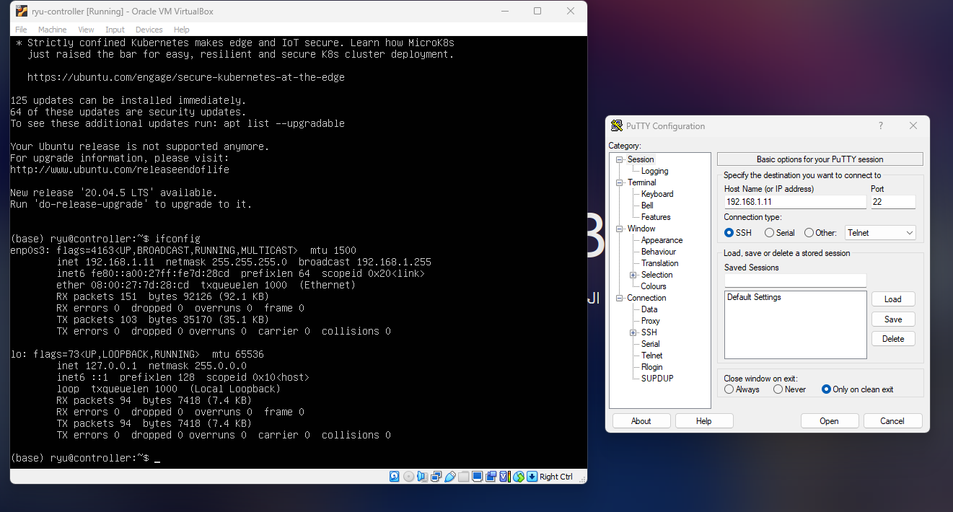Firstly, connect the ryu machine with putty to facilitate the communication between the ryu controller and the ubuntu machine as follows:

After connecting it .it should have the same ip add as we see

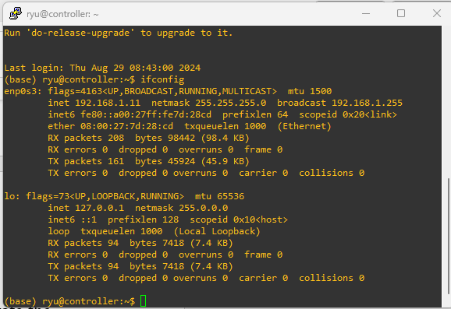

* 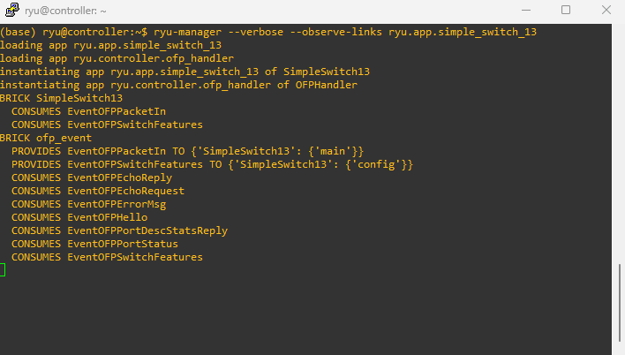Now up the ryu controller as follows:  
  **ryu-manager**: Launches the Ryu controller.
* **--verbose**: Provides detailed logging for debugging purposes.
* **--observe-links**: Enables the controller to monitor and react to changes in the network topology.
* **ryu.app.simple_switch_13**: Runs the simple OpenFlow 1.3 switch application provided by Ryu.
* This command is useful for setting up a basic Ryu controller with a simple switch application that supports OpenFlow 1.3, and it provides detailed logs and dynamic topology observation.

1. Now up the fat_topo with mininet with the changes in the ip and OpenFlow version 1.3 as follows:

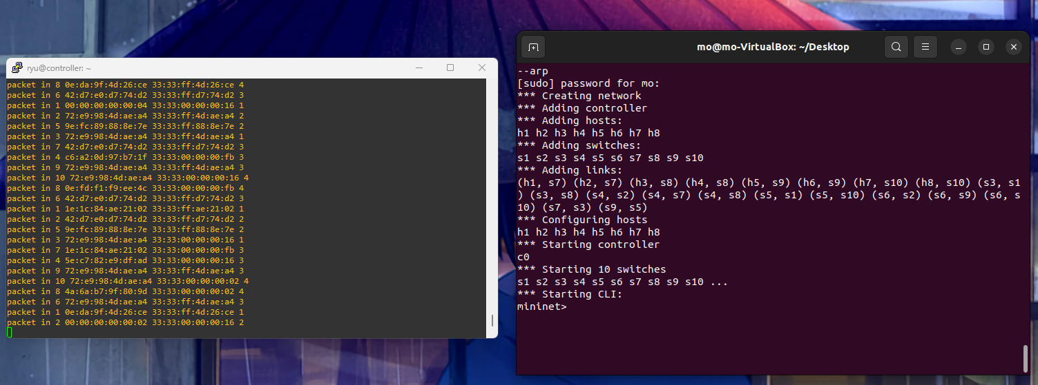

1. Now trying to pingall to test the reachability, it seems it has the same problem that faced with pox controller that there are loops in the topo as follows:  
   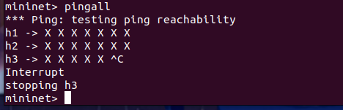
2. So I have got a solution from here [stp-mininet-ryu-tutorial/simple_switch_stp_13.py at master · fabiobento/stp-mininet-ryu-tutorial · GitHub](https://github.com/fabiobento/stp-mininet-ryu-tutorial/blob/master/simple_switch_stp_13.py)  
   this is an stp module that auotomate the protocol in the network and it works as espected as follows :

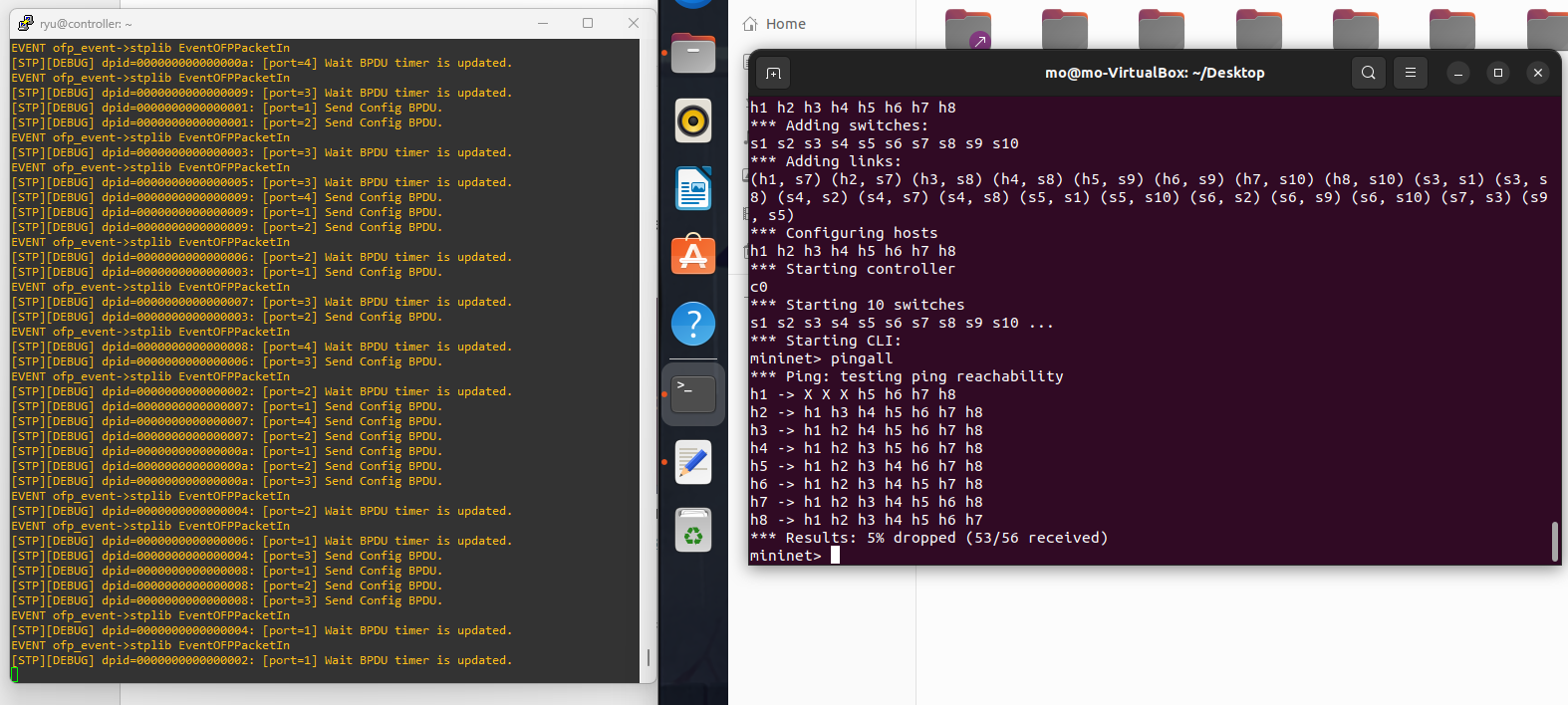  
 it takes time as I said to close some ports to forward the traffic this is the reason we see the first 3 host are un reachable at the first because the protocol was doing the analysis first and this takes processing time.this is the command used to up the controller with the stp module   
*$ ryu-manager --verbose --observe-links --ofp-tcp-listen-port 6689 simple_switch_stp_13.py*

1. So now let’s continue our qos tests starting with latency

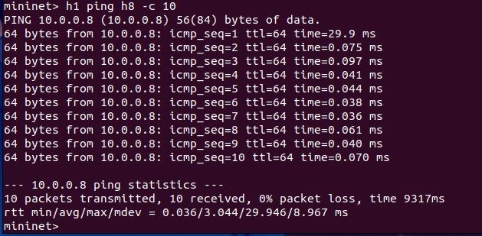

And here is the graph representation of the ping

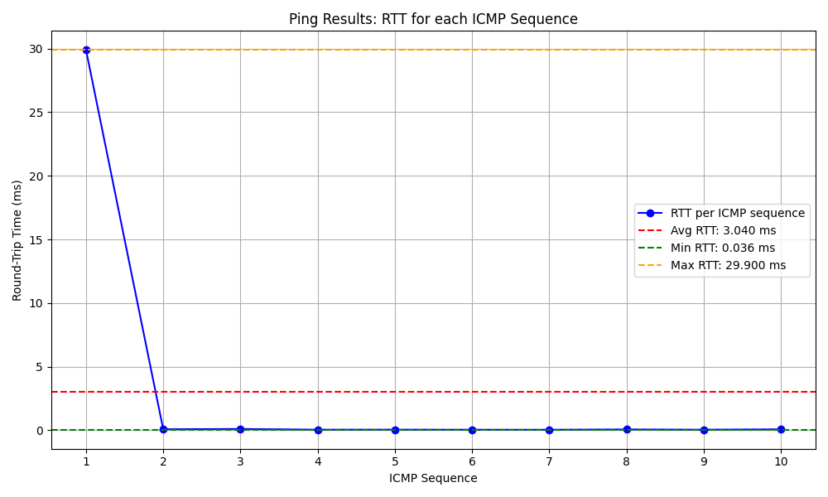

1. Now let’s test on the bandwidth with Iperf tool as follows:  
   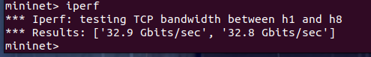

The first speed is the upload and the second is the download

1. Now let, s test on the throughput also with iperf (server/client communication)

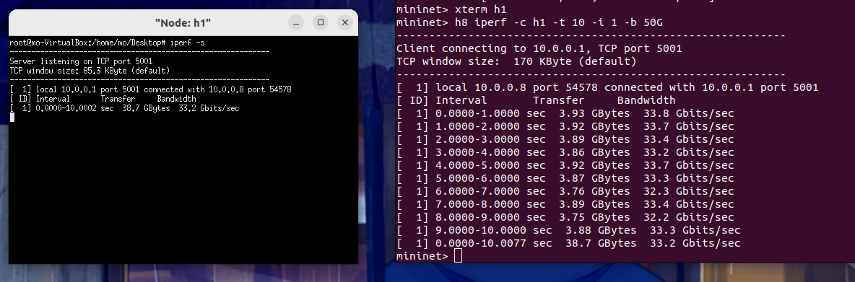

And here is the graph representation

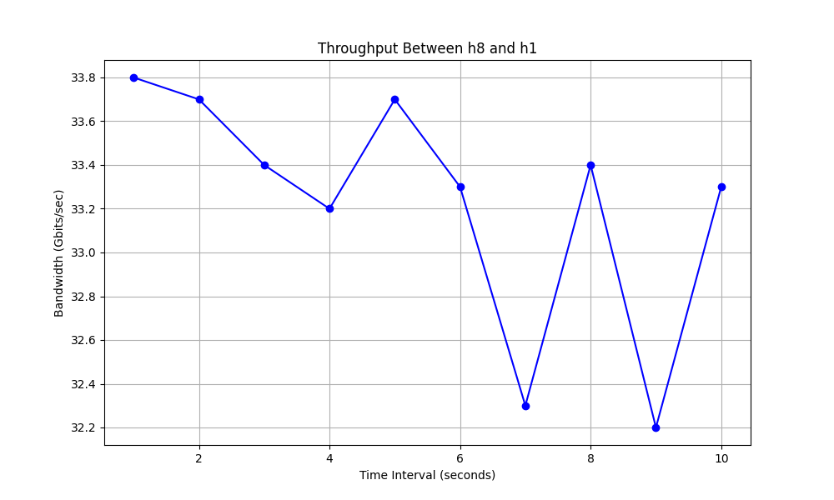

1. 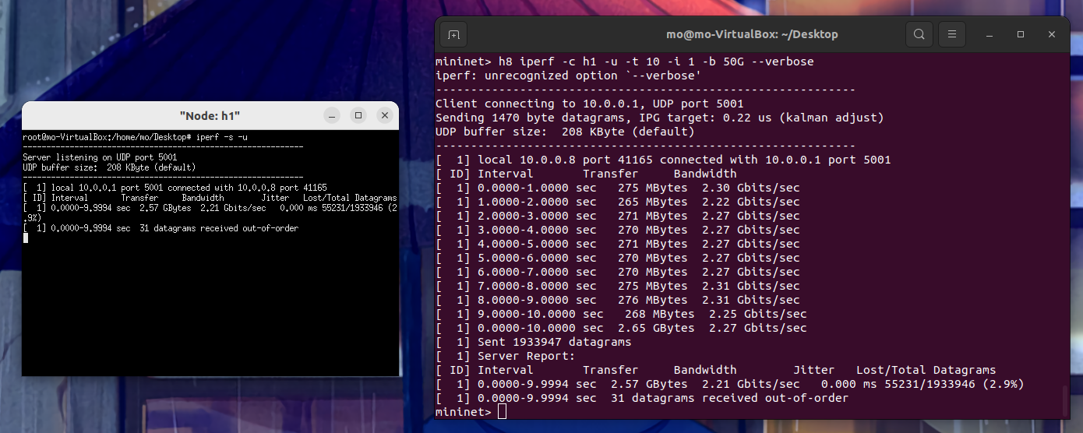Now let’s test the jitter and packet loss also with iperf  
   And here the graph representation of the test

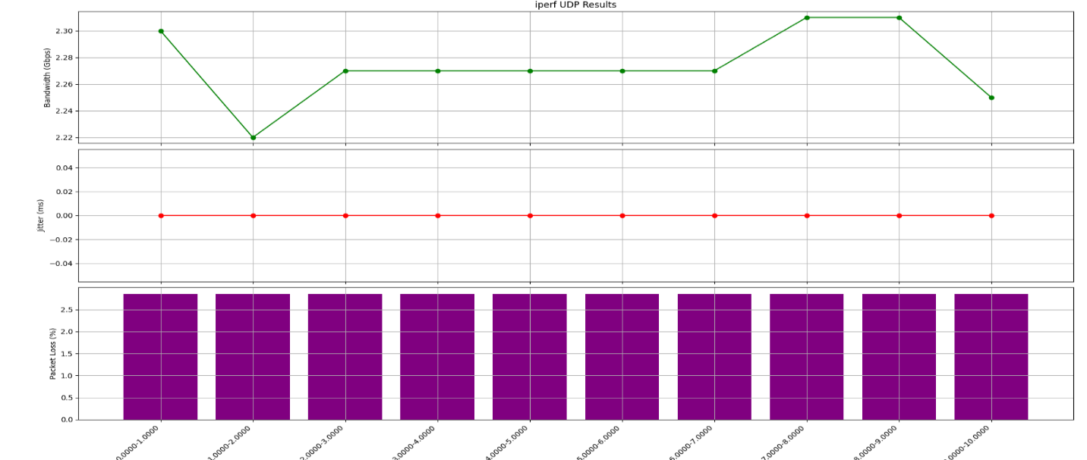  
note :ryu has a web gui app I tried to run it and the request is received by the controller but the gui does, t show the topo ,don’t know where the problem .So I will search on it later ^_^

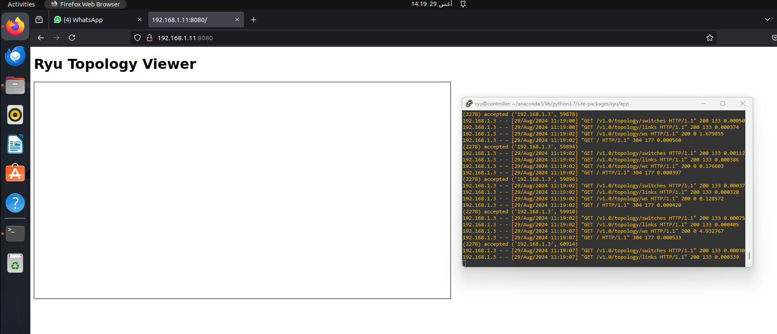

* **HPE-VAN**

1. 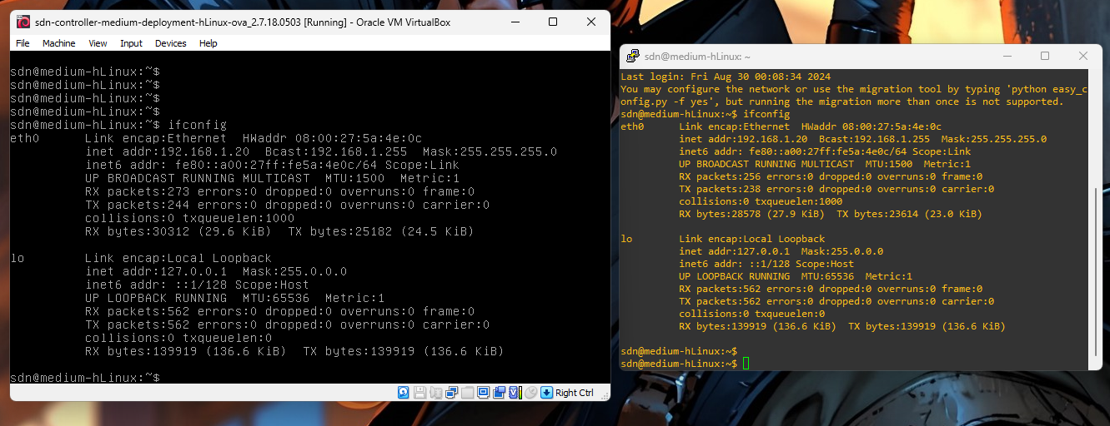Firstly, connect the hpe-van machine with putty as follows:
2. 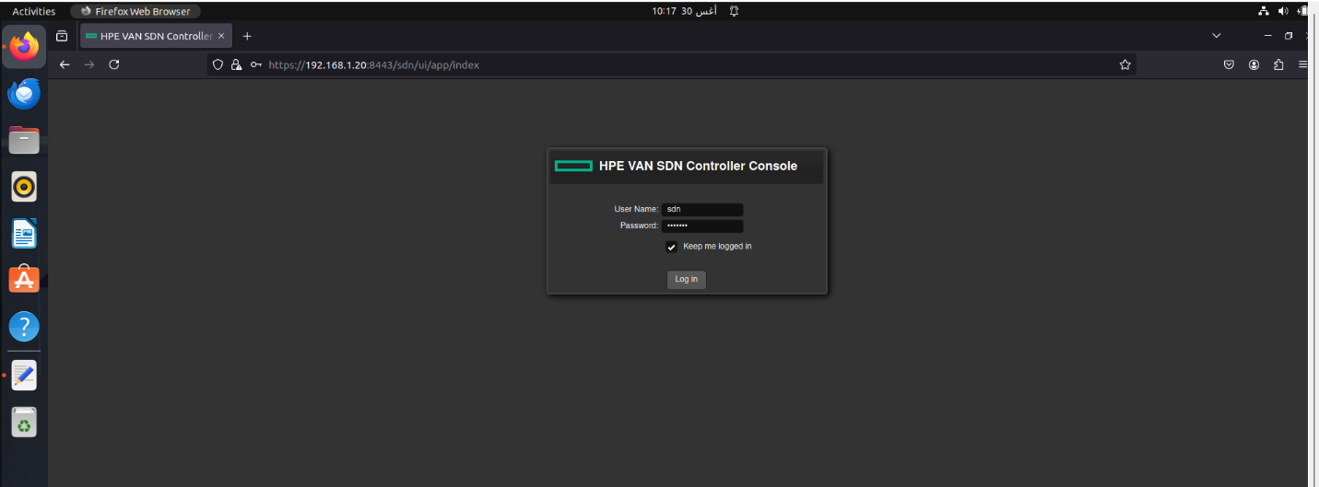Now let, s up the topo and connect it with controller (web gui app)  
   as I said before the gui app will open by running this url in the browser <https://192.168.1.20:8443> it should be open like this   
     
   now the app need authentication so enter the username : sdn  
   and the password : skyline .
3. After initiating the topo with the required ip address and the OpenFlow version 1.0. the controller capture the ovs as we see 10 but the hosts does, t appear this because I need to pingall to make the hosts visible it should be like this :  
   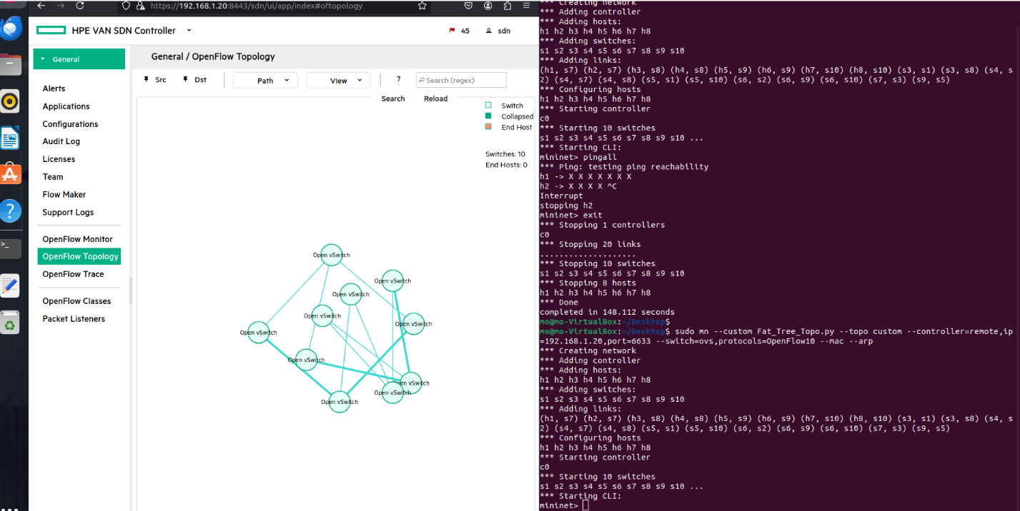
4. 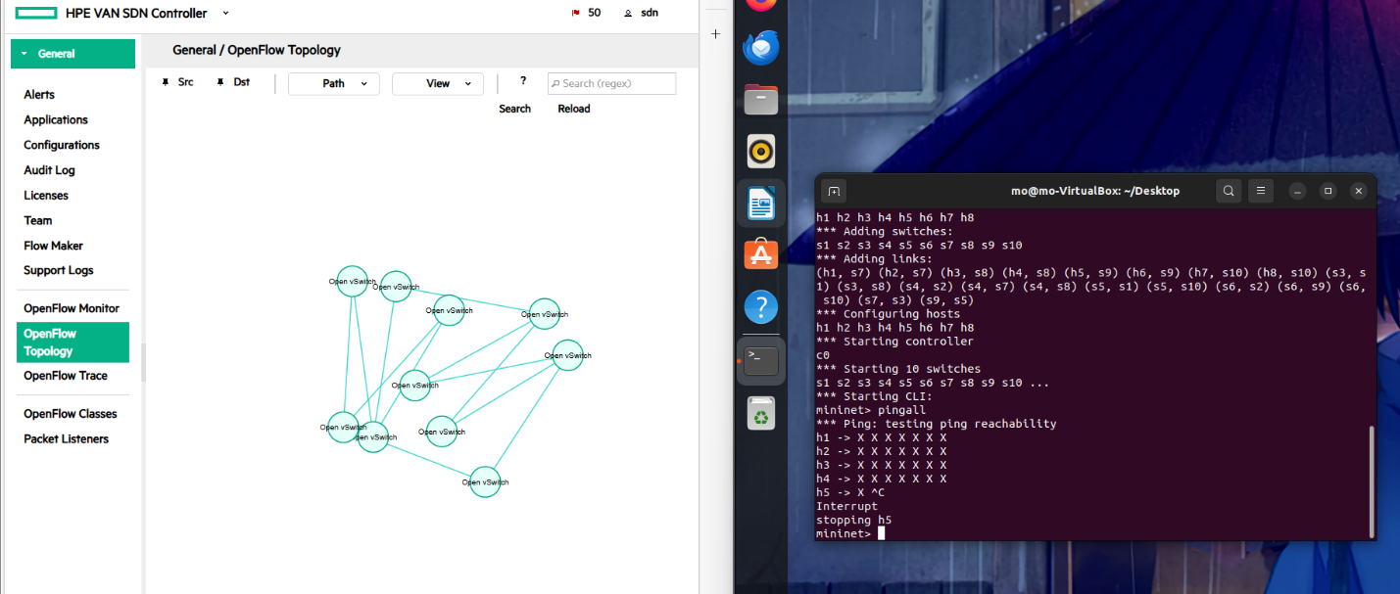But when I pingall the hosts unreachable this because as I said before there might be loops exists due to the multipaths in the topo. As I did in the pox and ryu I have to run the STP in the controller to get rid of loops that interrupt the network connectivity.So as we see here when I pingall all hosts unreachable to each other.
5. So I followed these page to solve the problem [Loop with SDN controller | SD-WAN (arubanetworks.com)](https://community.arubanetworks.com/discussion/loop-with-sdn-controller)

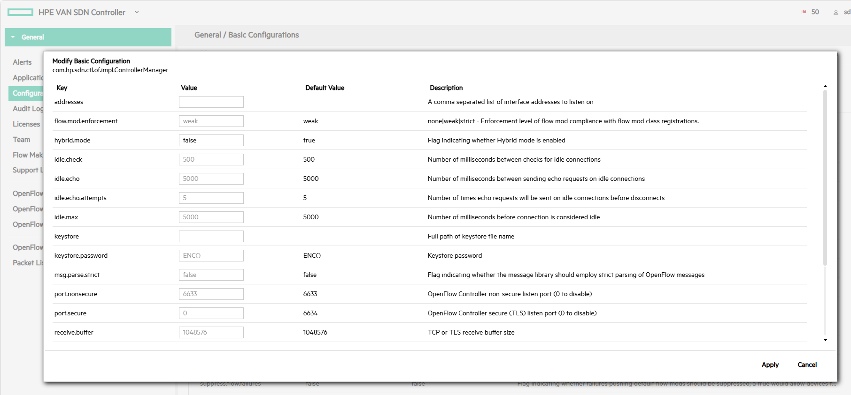

Then Restart the controller and mininet.

1. 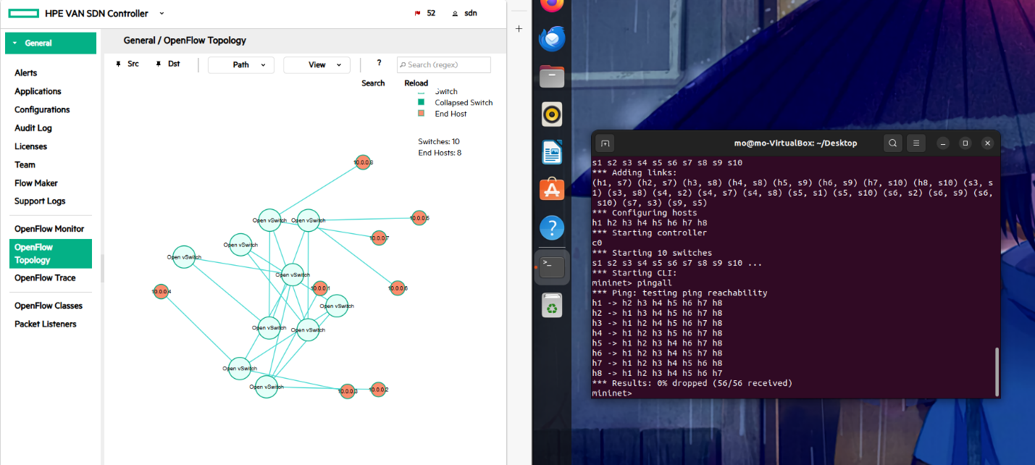And BOOM! it works

I can make the topo as fixed figure by pin all nodes as follows:

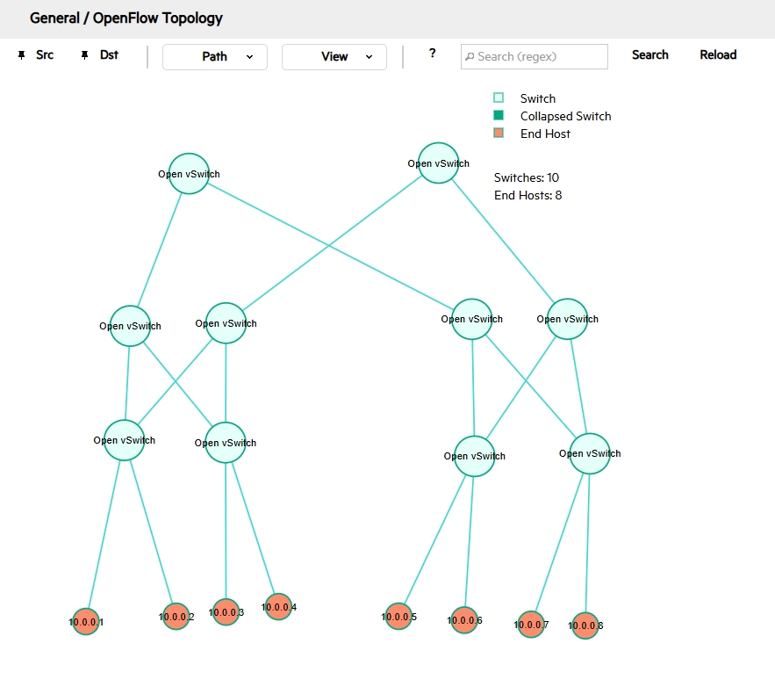

1. Now let,s start the qos tests starting with latency as we are used to

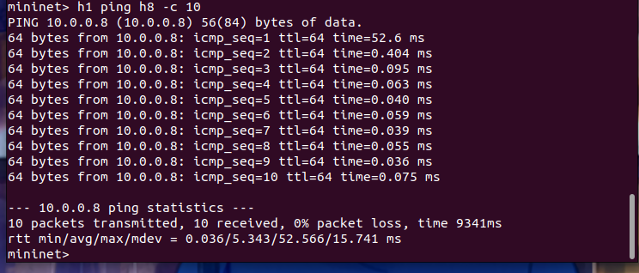

And here is the graph representation of the ping

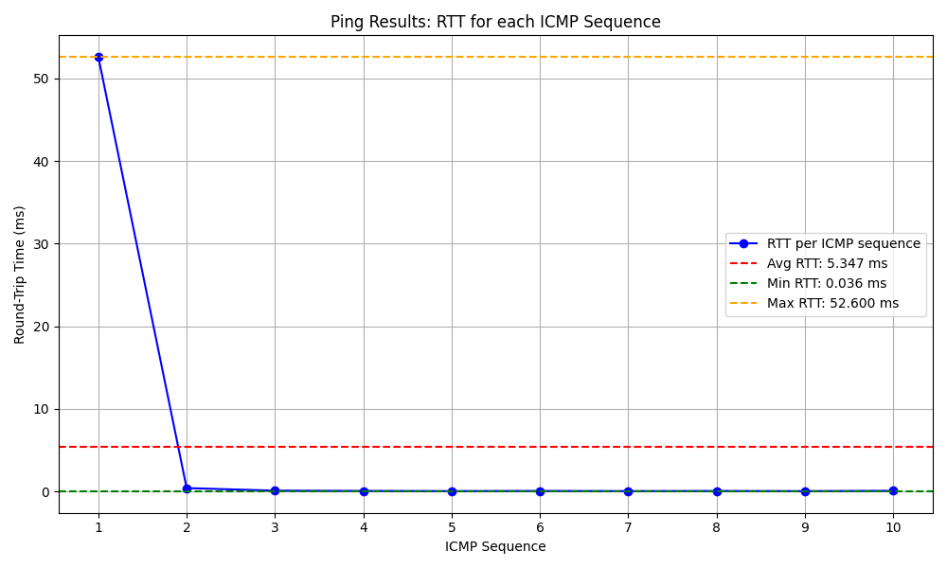

1. Now let’s test on the bandwidth with Iperf tool as follows:
2. 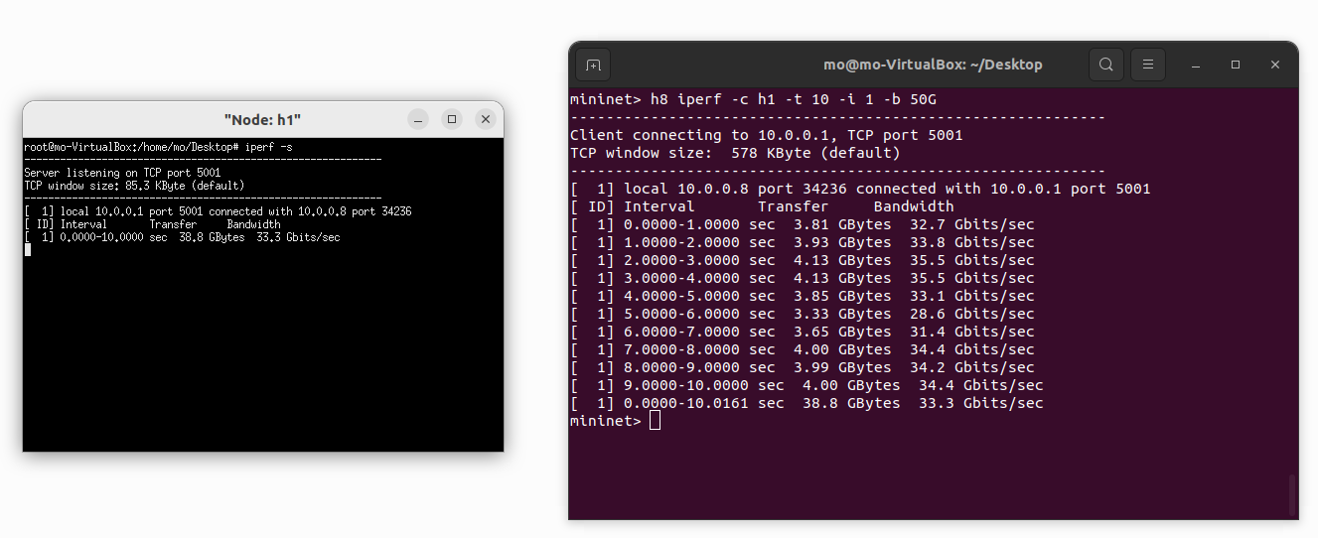Now let, s test on the throughput also with iperf (server/client communication)

And here is the graph representation

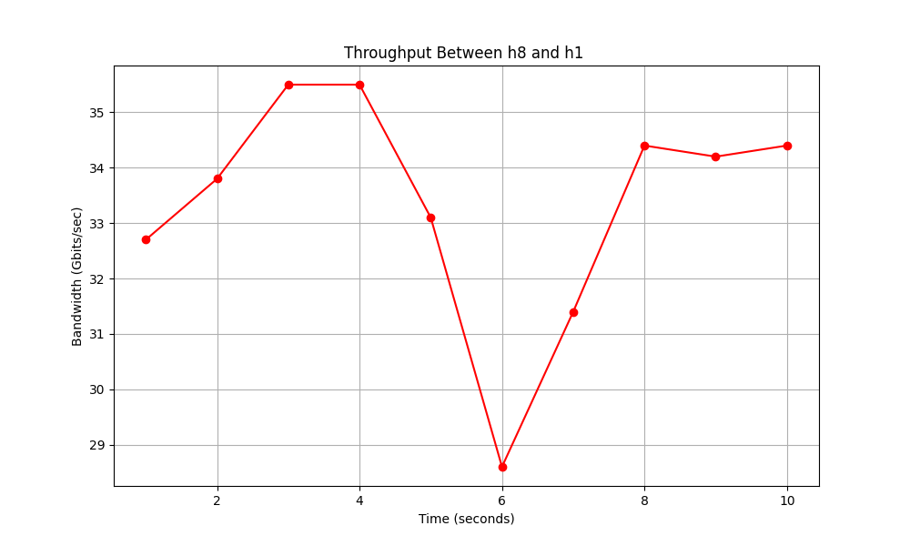

1. Now let’s test the jitter and packet loss also with iperf

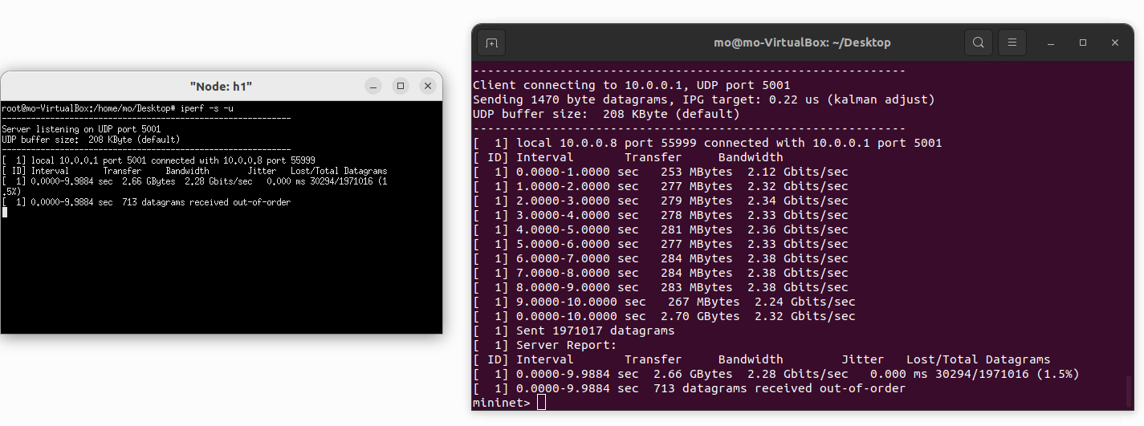

here is the graph representation

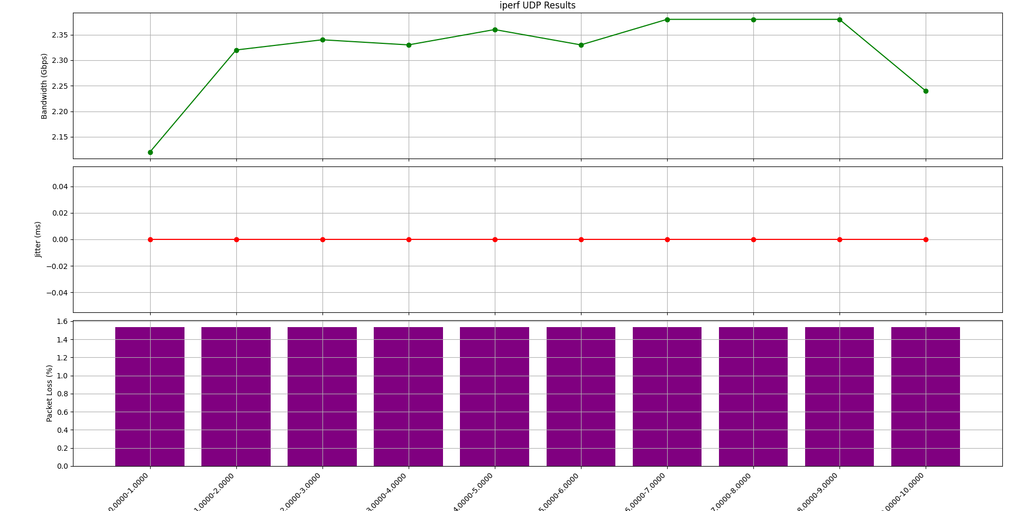

As we see that HPE-VAN displays a dynamic gui application to see all the network with an awesome view.

* **OPENDAYLIGHT**

1. To run the ODL make sure that you’re in the bin directory of the odl controller and make sure that the working java version is 8 if not you can make it like in the following screenshot:

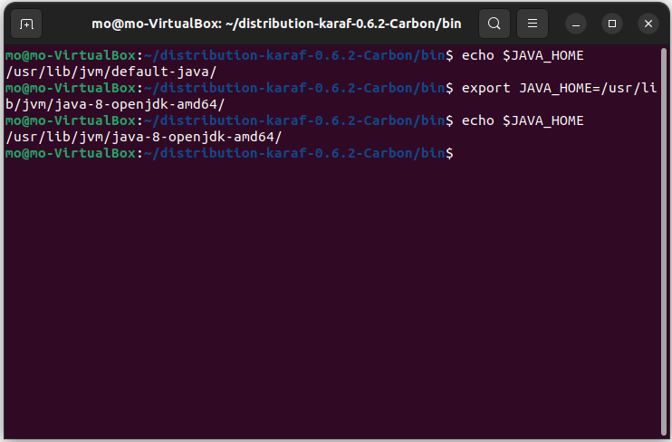

Now execute the karaf file by typing *$./karaf* in the terminal and it should be like this   
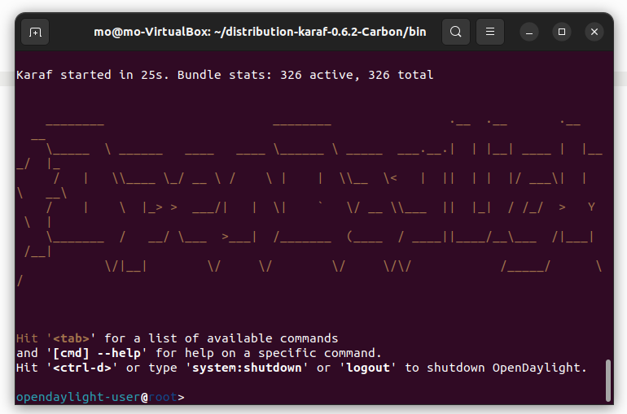

1. 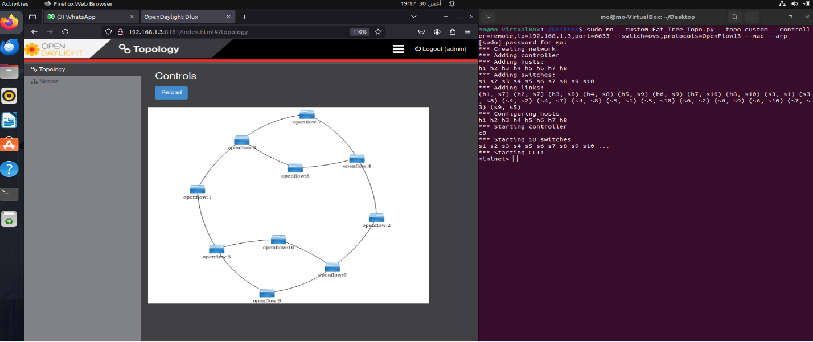Now open the gui app by running the following url <http://x.x.x.x:8181/index.html> and up the topology also to display with changing the ip and the OpenFlow version as I said before as follows:
2. 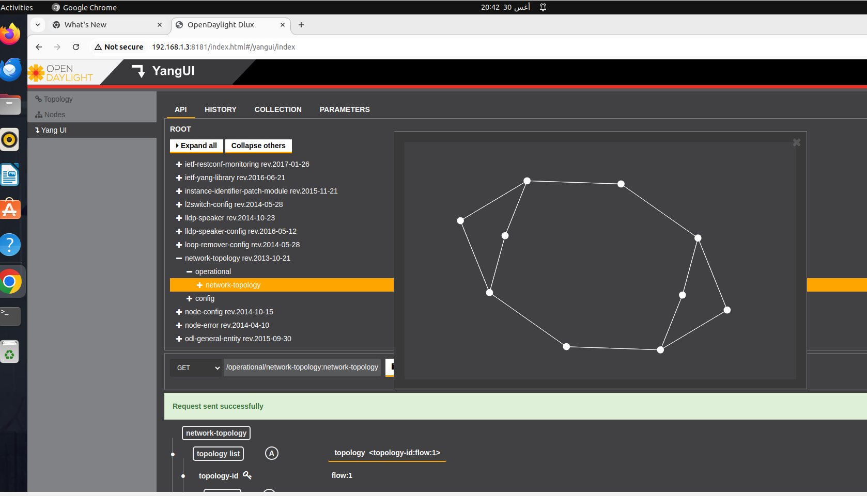Now as we used to I need to pingall to see the hosts but it does not appares I don,t know what is the problem I tried to see it also in Yang UI but the hosts does not appare although the ping is working perfectly :

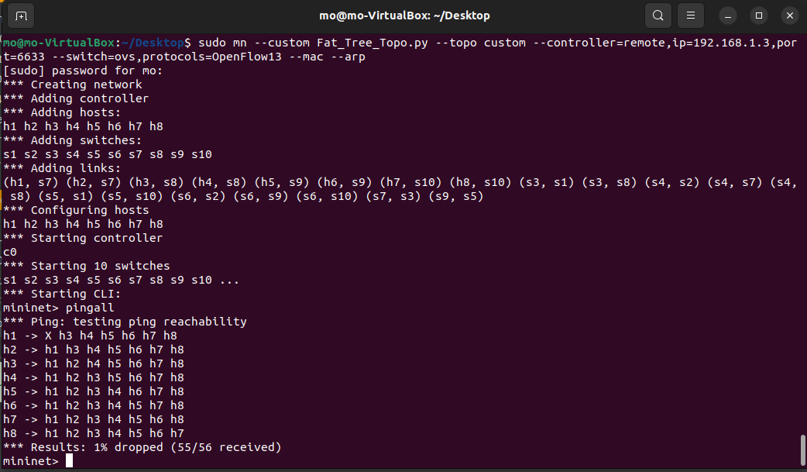 The pingall works perfectly

1. 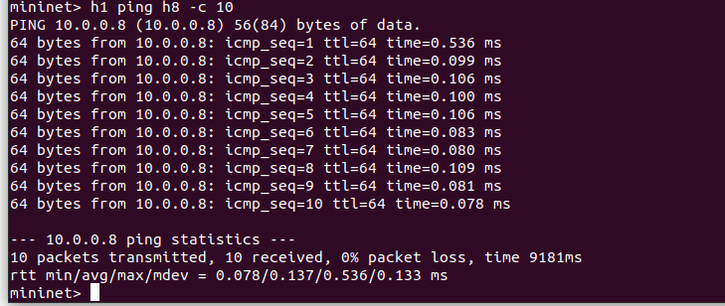Anyway, I continued my qos testing starting with latency

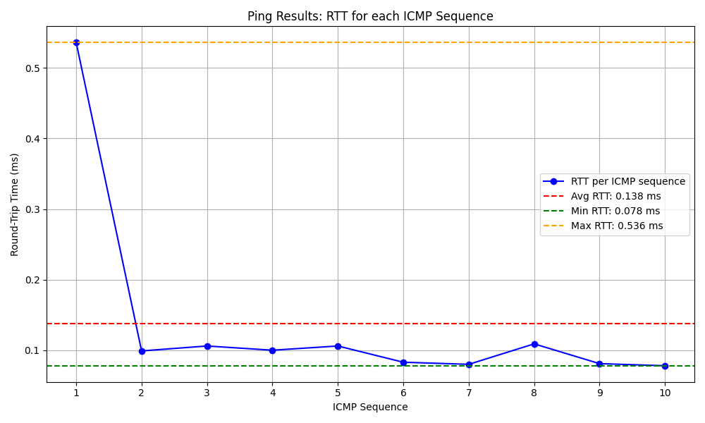And here is the graph representation of the ping

1. 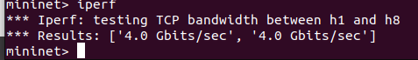Now let’s test on the bandwidth with Iperf tool as follows:
2. Now let, s test on the throughput also with iperf (server/client communication)

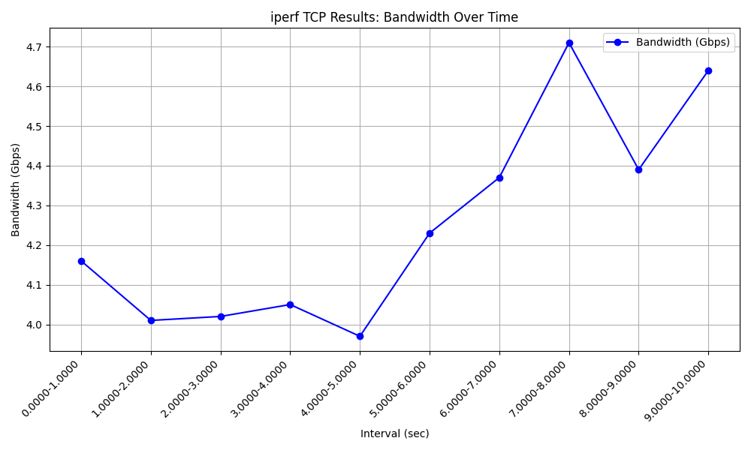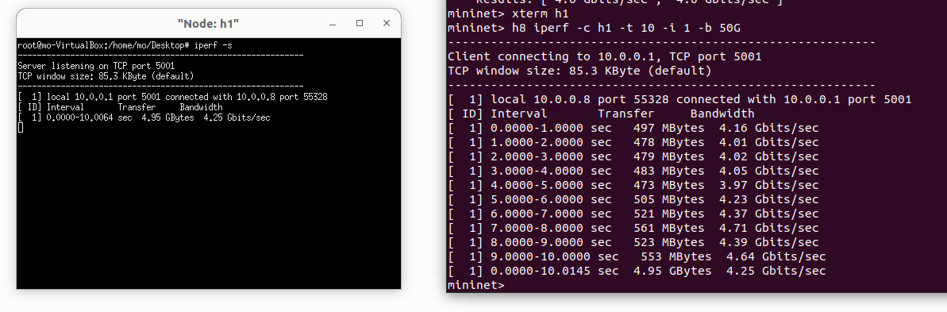And here is the graph representation

1. 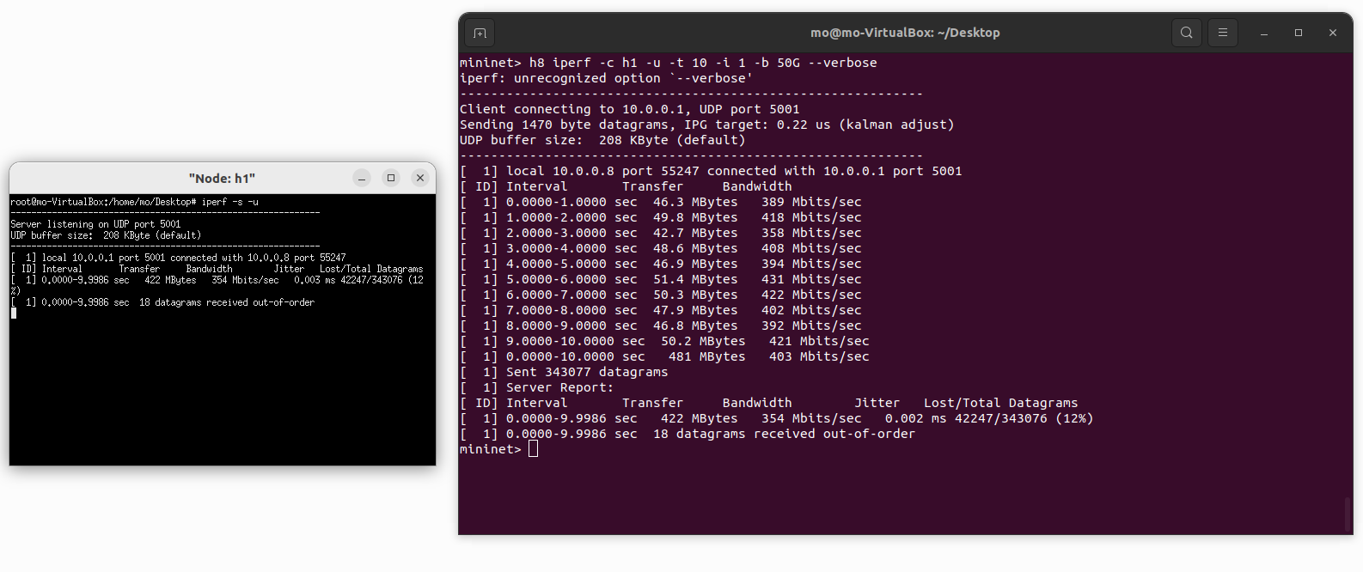Now let’s test the jitter and packet loss also with iperf

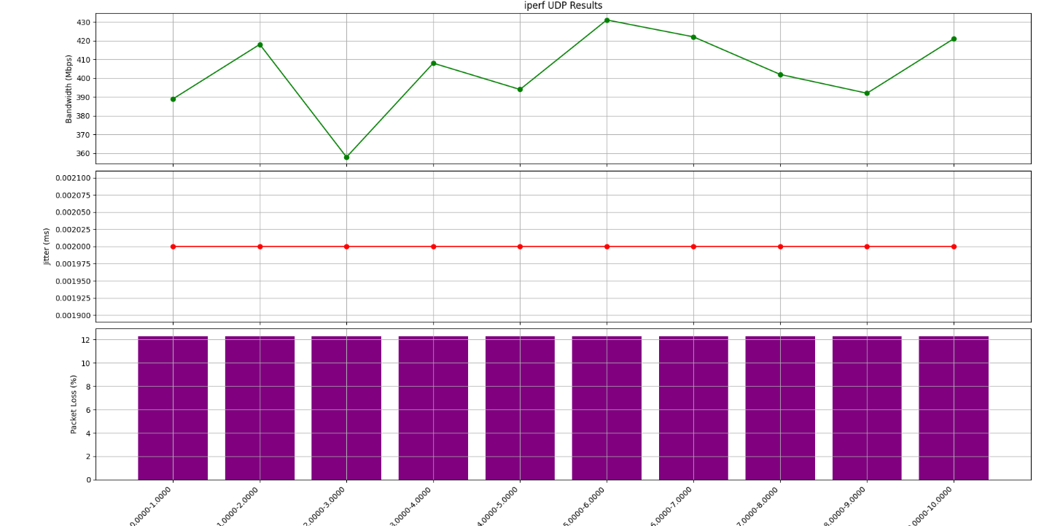 And here is the graph representation

* **ONOS**

1. 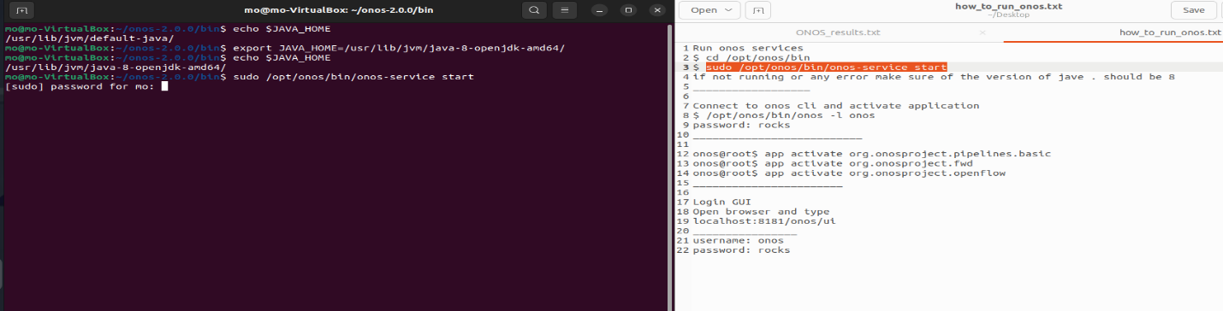Firstly, check that the running version of java is 8 and then go to the bin directory of onos to run the onos service:

after opening onos activate these three apps as follows:

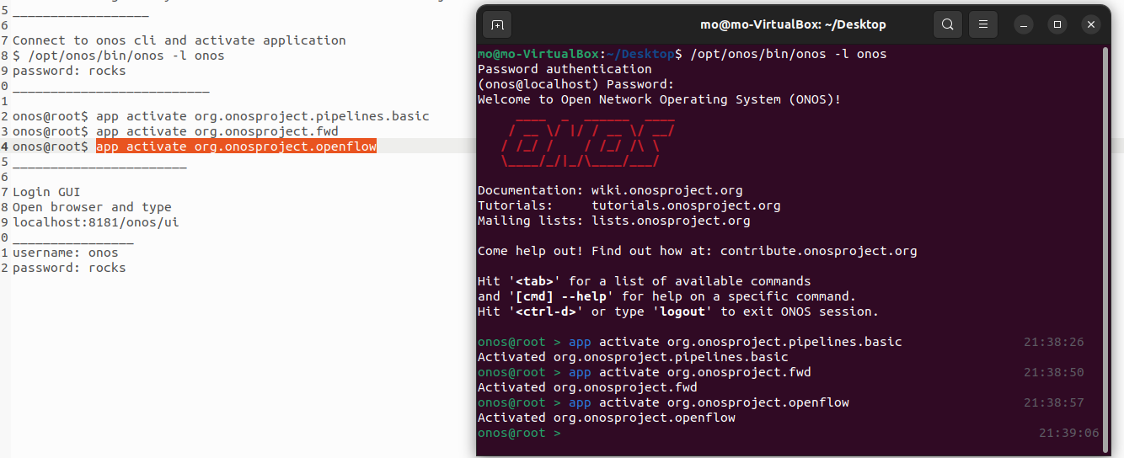  
now login to the gui through this url localhost:8181/onos/ui and it ask for authentication so the username: onos and password: rocks so it should be in now.

1. 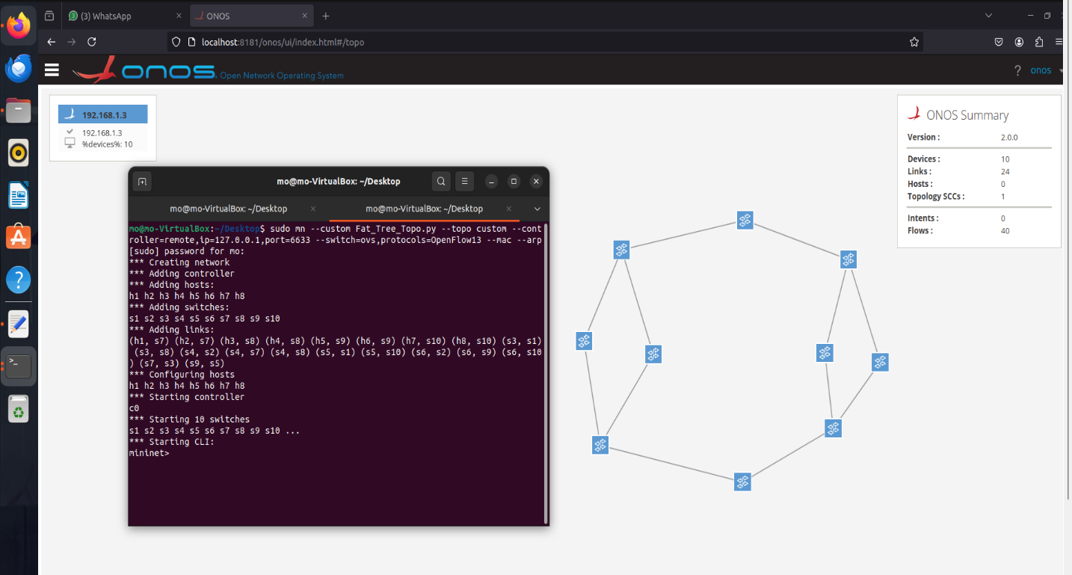Now up the topo with changing the ip and the OpenFlow version as follows:

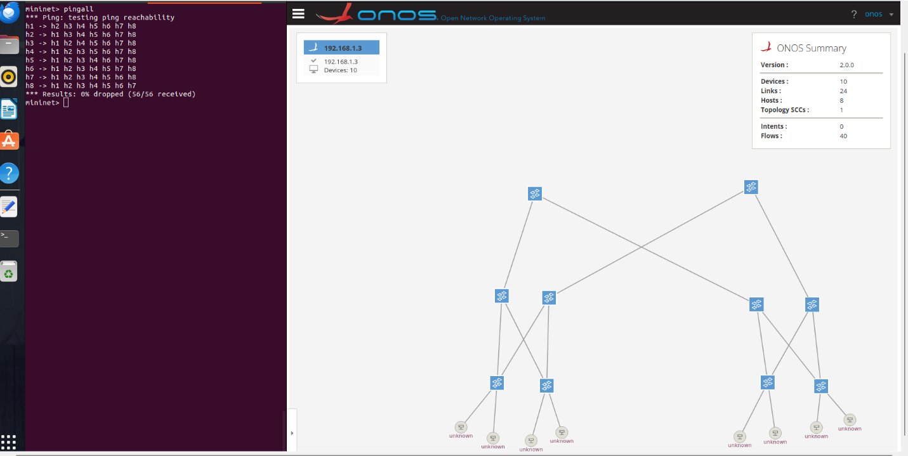Now pingall to see the hosts and see if all hosts are reachable

As we see the hosts now are visible, but I do not know why the controller cannot read the ip in the gui of the topo although it captures the number of hosts and the pingall works perfectly so I think this is not a big problem.

1. 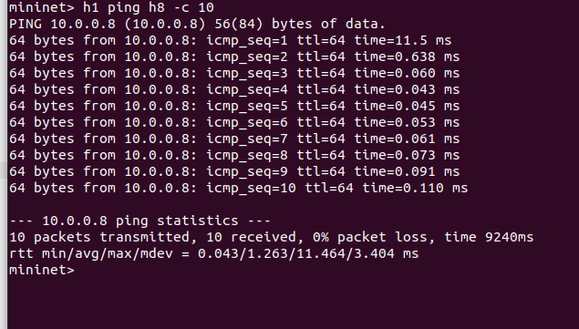Now let,s continue with our qos tests starting with latency

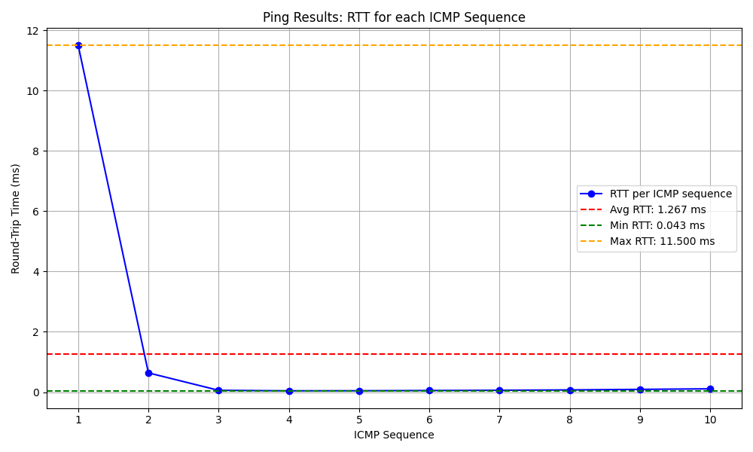And here is the graph presentation

1. 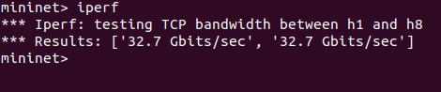Now let’s test on the bandwidth with Iperf tool as follows:
2. 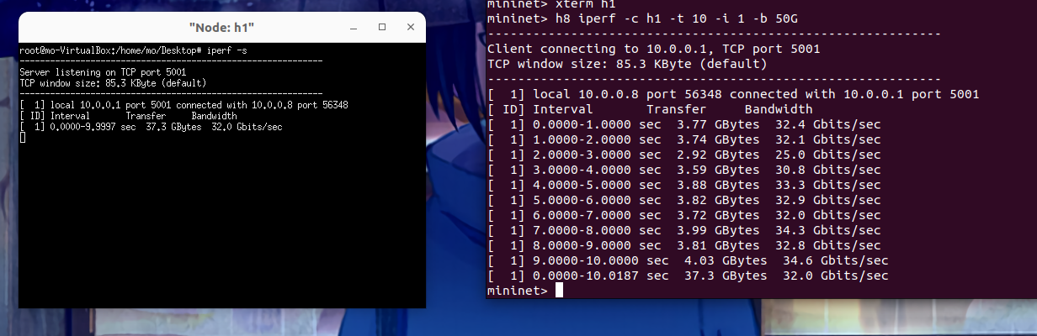Now let, s test on the throughput also with iperf (server/client communication):

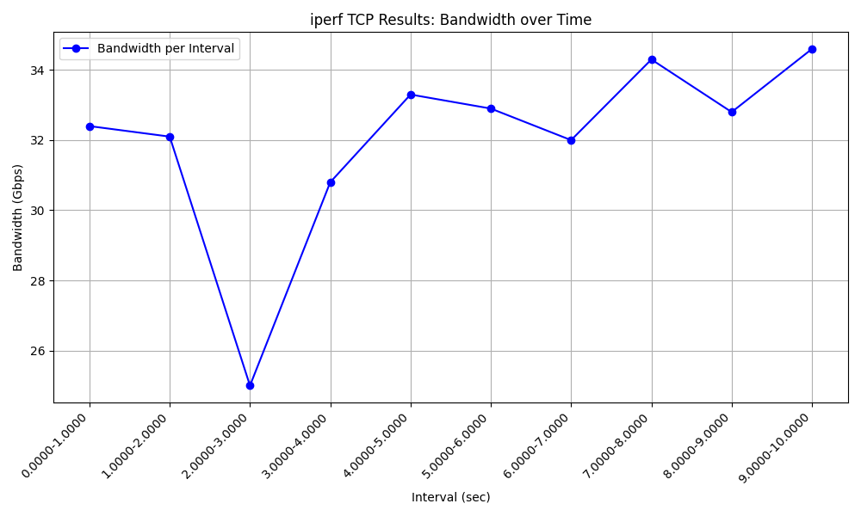And here is the graph representation

1. 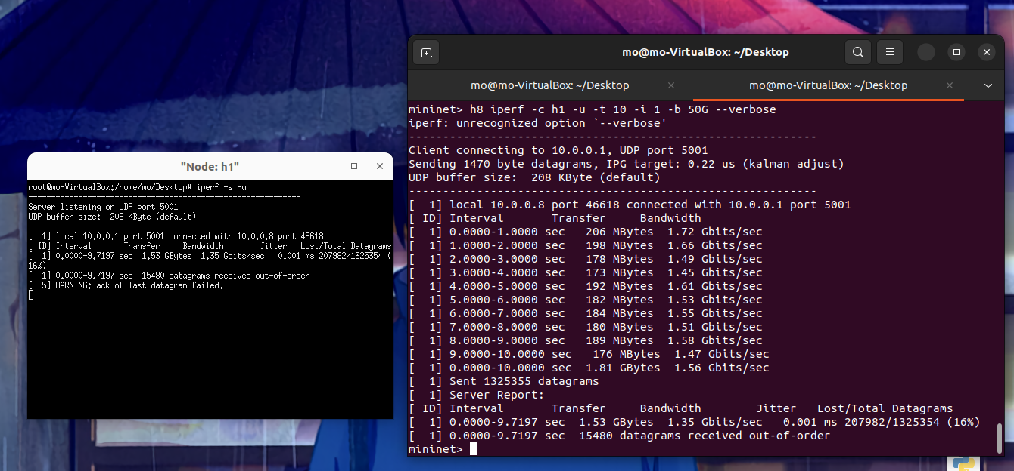Now let’s test the jitter and packet loss also with iperf

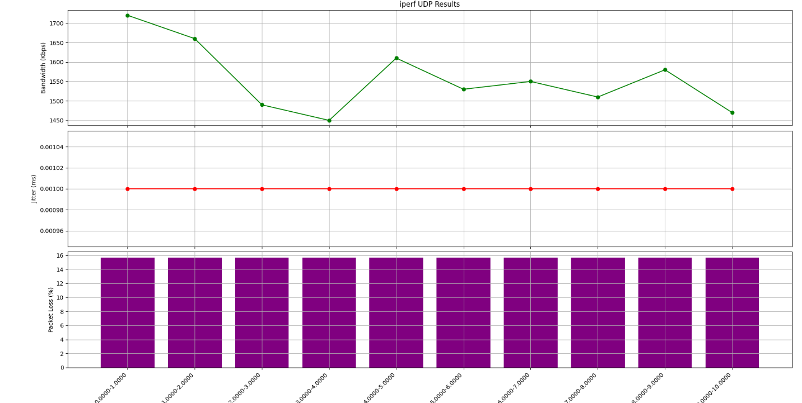And here is the graph representation

**4. Results**

I will Present the results in a clear and organized manner using tables, graphs of each QOS parameter in the five controllers too see who is the best one in this parameter.

1. 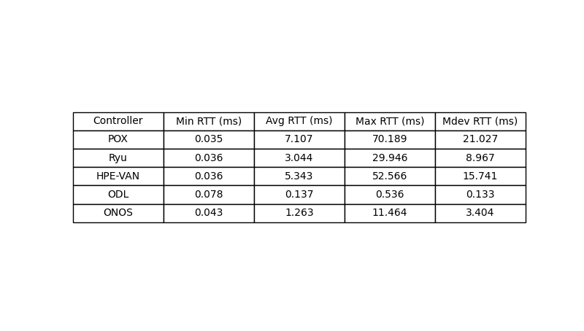**Latency**

Based on the results in terms of latency, which is measured by the Round-Trip Time (RTT), the best controller is the one with the lowest average RTT. Here's the breakdown of the average RTT for each controller:

- POX: 7.107 ms

- Ryu: 3.044 ms

- HPE-VAN: 5.343 ms

- ODL: 0.137 ms

- ONOS: 1.263 ms

**Conclusion:**

ODL (OpenDaylight) has the lowest average RTT of 0.137 ms, making it the best in terms of latency among the controllers tested.

And here is the graph representation to clarify that ODL is the best in the latncy:

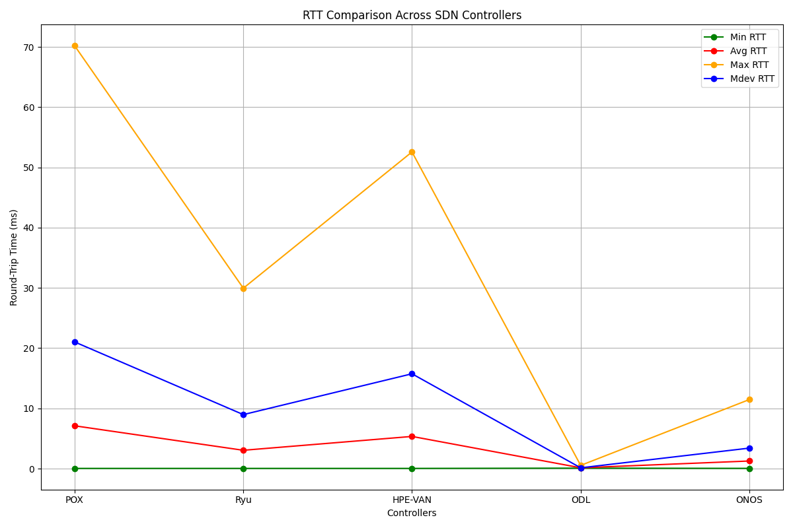

1. 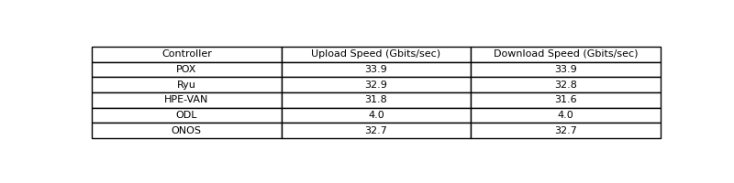**Bandwidth**

Based on the bandwidth values provided:

- POX: 33.9 Gbits/sec (Upload), 33.9 Gbits/sec (Download)

- Ryu: 32.9 Gbits/sec (Upload), 32.8 Gbits/sec (Download)

- HPE-VAN: 31.8 Gbits/sec (Upload), 31.6 Gbits/sec (Download)

- ODL: 4.0 Gbits/sec (Upload), 4.0 Gbits/sec (Download)

- ONOS: 32.7 Gbits/sec (Upload), 32.7 Gbits/sec (Download)

**Conclusion**:

- POX has the highest bandwidth for both upload and download speeds at 33.9 Gbits/sec.

- Ryu is the second-best with slightly lower speeds at 32.9 Gbits/sec (Upload) and 32.8 Gbits/sec (Download).

- ONOS is close to Ryu, with 32.7 Gbits/sec for both upload and download.

- HPE-VAN follows with 31.8 Gbits/sec (Upload) and 31.6 Gbits/sec (Download).

- ODL has the lowest bandwidth at 4.0 Gbits/sec for both upload and download.

POX is the best controller based on the bandwidth results.

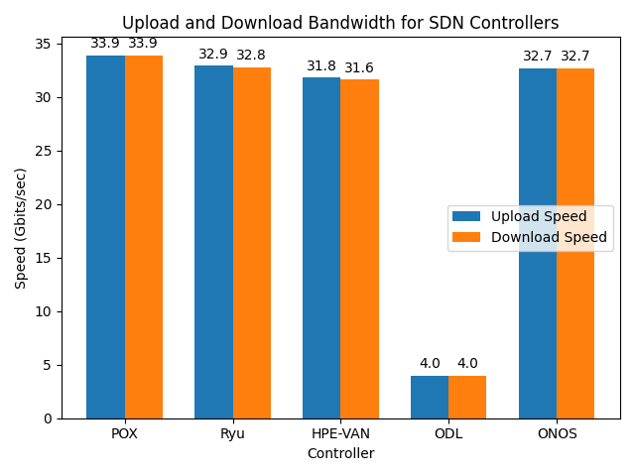And here is the graph representation to clarify that POX is the best in the BW:

1. 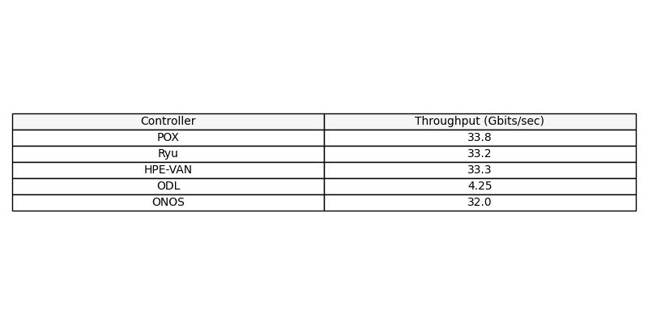**Throughput**

Based on the throughput results from the five SDN controllers, here’s a summary of their performance:

- POX has the highest throughput at 33.8 Gbits/sec.

- Ryu and HPE-VAN are very close, with Ryu at 33.2 Gbits/sec and HPE-VAN at 33.3 Gbits/sec.

- ONOS has a similar throughput to Ryu and HPE-VAN but slightly lower at 32.0 Gbits/sec.

- ODL shows significantly lower throughput at 4.25 Gbits/sec.

**Conclusion**:

POX is the best performer in terms of throughput among the controllers tested. It provides the highest bandwidth, making it the most efficient in this particular metric. Ryu and HPE-VAN are also strong contenders, with comparable performance close to POX, while ONOS and ODL show lower throughput.

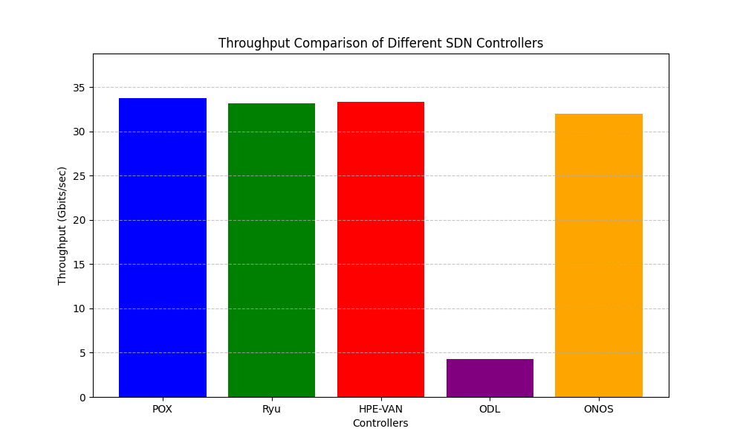And here is the graph representation to clarify that POX is the best in the throughput:

**iv. jitter and packet loss**

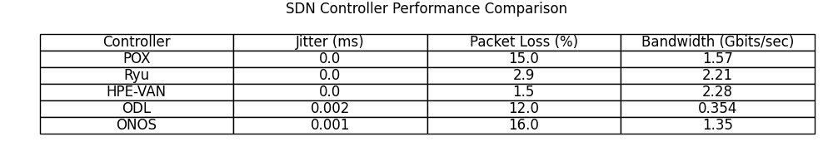

To determine the best SDN controller based on the provided values for Jitter (ms), Packet Loss (%), and Bandwidth (Gbits/sec), we need to consider the following criteria:

1. Jitter (ms): Lower jitter is better.

2. Packet Loss (%): Lower packet loss is better.

3. Bandwidth (Gbits/sec): Higher bandwidth is better.

Given the data:

- Jitter (ms):

- POX: 0.000

- Ryu: 0.000

- HPE-VAN: 0.000

- ODL: 0.002

- ONOS: 0.001

Best for Jitter: All of POX, Ryu, and HPE-VAN have the best jitter performance with 0.000 ms.

- Packet Loss (%):

- POX: 15

- Ryu: 2.9

- HPE-VAN: 1.5

- ODL: 12

- ONOS: 16

Best for Packet Loss: HPE-VAN is the best with the lowest packet loss of 1.5%.

- Bandwidth (Gbits/sec):

- POX: 1.57

- Ryu: 2.21

- HPE-VAN: 2.28

- ODL: 0.354

- ONOS: 1.35

Best for Bandwidth: HPE-VAN has the best bandwidth performance at 2.28 Gbits/sec.

**Overall Best: HPE-VAN**

HPE-VAN is the best performer across all three metrics:

- Tied for Best Jitter: 0.000 ms

- Best Packet Loss: 1.5%

- Best Bandwidth: 2.28 Gbits/sec

Thus, HPE-VAN is the top choice based on these criteria.

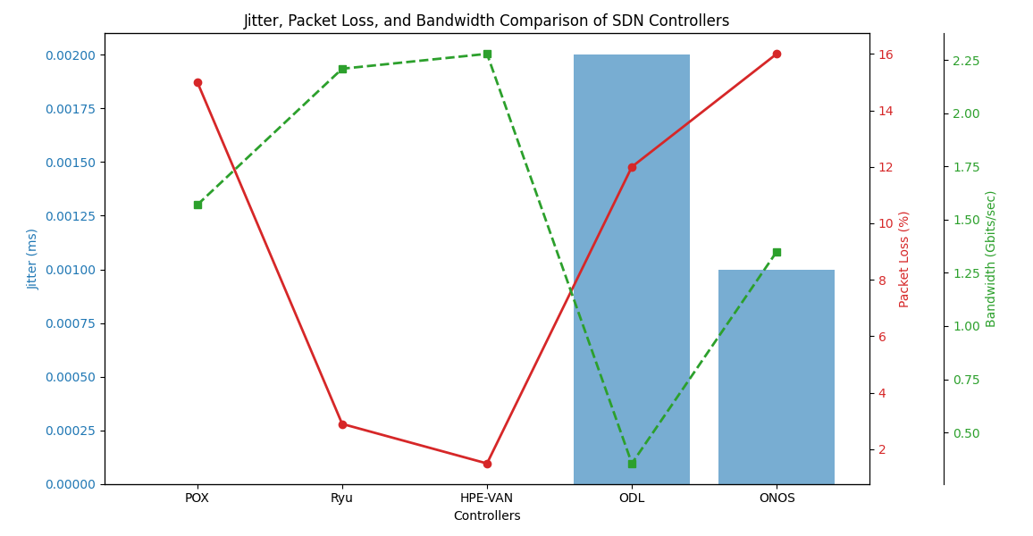   
 And here is the graph representation to clarify that HPE-VAN is the best in the three qos parameters:

**5. Discussion**

**Performance Insights:**

The performance of the SDN controllers tested (POX, Ryu, HPE-VAN, ODL, and ONOS) varied significantly across different Quality of Service (QoS) parameters. This section provides insights into why certain controllers performed better or worse in specific metrics, considering factors such as controller architecture, default configurations, and protocol implementations.

**- Latency:**

OpenDaylight (ODL) demonstrated the lowest latency with an average Round-Trip Time (RTT) of 0.137 ms. This superior performance in latency could be attributed to ODL's efficient handling of control plane operations, possibly due to its modular architecture and robust southbound interface, which minimizes processing delays.

**- Bandwidth:**

POX emerged as the leader in bandwidth, achieving 33.9 Gbits/sec for both upload and download speeds. POX’s architecture, which emphasizes simplicity and lightweight operations, may allow it to handle higher data rates more effectively than its counterparts, despite being an older controller. However, it's important to note that Ryu and ONOS followed closely, indicating that these controllers also manage data flows efficiently in scenarios demanding high bandwidth.

**- Throughput:**

The highest throughput was observed in POX, at 33.8 Gbits/sec. The throughput results suggest that POX is particularly well-optimized for scenarios requiring high data transfer rates, likely due to its streamlined process handling and minimal overhead in flow processing.

**- Jitter:**

In terms of jitter, POX, Ryu, and HPE-VAN all achieved 0.000 ms, indicating extremely stable performance with no noticeable variation in packet timing. This could be due to their effective packet scheduling and handling mechanisms, which ensure consistent delivery times across the network.

**- Packet Loss:**

HPE-VAN showed the best performance in packet loss, with only 1.5% loss. This low packet loss rate can be attributed to HPE-VAN's advanced error detection and recovery mechanisms, which are crucial for maintaining data integrity in large-scale networks.

**- Overall Performance:**

HPE-VAN stands out as the overall best performer when considering jitter, packet loss, and bandwidth together. Its architecture and protocol implementations seem particularly well-suited for maintaining high QoS standards across various network conditions.

These results highlight the strengths and weaknesses of each controller, providing valuable insights for choosing the right controller based on specific network requirements. The variations in performance are influenced by each controller's design philosophy, the version used, and the optimizations present in their default configurations. Notably, the versions used in this research were the last version of POX, Ryu version 4.32, HPE-VAN version 2.7, ODL version Carbon 0.6.2, and ONOS version Quail 2.0.0.

**Real-World Implications**

The performance results obtained from testing the SDN controllers (POX, Ryu, HPE-VAN, ODL, and ONOS) provide critical insights into their suitability for various real-world network environments. These results can guide network administrators and architects in selecting the most appropriate controller based on specific application requirements and network conditions.

**- Latency-Critical Applications:**

For environments where low latency is paramount, such as high-frequency trading platforms or real-time communication systems, OpenDaylight (ODL) emerges as the best choice. With the lowest average latency of 0.137 ms, ODL ensures rapid response times and minimal delays, making it ideal for scenarios where every millisecond counts.

**- High-Bandwidth Networks:**

Networks requiring high data throughput, such as data centers, content delivery networks (CDNs), or cloud service providers, would benefit most from using POX. With the highest bandwidth and throughput figures (33.9 Gbits/sec), POX is well-suited to handle large volumes of data traffic efficiently, ensuring optimal performance in environments with heavy data flows.

**- Stable and Reliable Networks:**

For applications where jitter and packet loss are critical, such as video streaming, VoIP, or online gaming, HPE-VAN is the most reliable controller. Its perfect jitter score of 0.000 ms and the lowest packet loss rate of 1.5% indicate that HPE-VAN can maintain consistent network performance, ensuring smooth and uninterrupted service delivery.

**- General-Purpose Networks:**

Ryu, with its balanced performance across latency, bandwidth, and jitter, is a strong candidate for general-purpose networks that require reliable, all-around performance. This includes enterprise networks, educational institutions, and small to medium-sized businesses where the network needs to support a variety of applications with reasonable efficiency.

**- Cost-Effective and Lightweight Deployments:**

POX, being a lightweight and straightforward controller, may also be suitable for cost-sensitive deployments or smaller networks where advanced features are less critical. Its simplicity and ease of use make it an attractive option for educational purposes, research environments, or small-scale networks where ease of deployment and management are key considerations.

**- Large-Scale and Complex Networks:**

For large-scale networks that demand advanced features and robust control, ONOS and HPE-VAN offer a strong foundation. ONOS, with its focus on scalability and distributed control, is particularly well-suited for service providers or national research networks that need to manage vast and complex infrastructures. HPE-VAN, with its overall best performance in key QoS metrics, is ideal for enterprise-level networks that require high reliability, efficiency, and performance.

In conclusion, the choice of SDN controller should be aligned with the specific needs of the network and its intended applications. While ODL excels in latency, POX dominates in bandwidth and throughput, and HPE-VAN offers the best overall reliability, each controller has strengths that make it better suited for particular real-world scenarios.

**6. Conclusion**

**Summary of Findings**

This research has thoroughly evaluated the performance of five prominent SDN controllers (POX, Ryu, HPE-VAN, ODL, and ONOS) across various QoS parameters, including latency, jitter, packet loss, bandwidth, and throughput. The key findings are:

- Latency: ODL emerged as the best performer with the lowest average latency, making it highly suitable for latency-sensitive applications.

- Bandwidth and Throughput: POX demonstrated the highest bandwidth and throughput, indicating its capability to handle large volumes of data traffic efficiently.

- Jitter and Packet Loss: HPE-VAN excelled in providing the lowest jitter and packet loss, ensuring stable and reliable network performance.

- Overall Performance: HPE-VAN proved to be the most balanced controller across all tested parameters, making it a versatile choice for a wide range of network environments.

While each controller has specific strengths, some weaknesses were also identified. ODL, despite its low latency, exhibited significantly lower bandwidth and throughput. ONOS showed moderate performance across most parameters but did not excel in any particular area. POX and Ryu delivered strong results in bandwidth and throughput but fell short in jitter and packet loss.

**Recommendations**

Based on the findings, the following recommendations are provided:

- Latency-Critical Applications: ODL is recommended for environments where low latency is crucial, such as real-time communication systems or high-frequency trading platforms.

- High-Bandwidth Networks: POX is the best choice for networks that require high data throughput, such as data centers or content delivery networks.

- Reliable and Stable Networks: HPE-VAN is recommended for applications where network stability and reliability are paramount, such as video streaming, VoIP, or online gaming.

- General-Purpose Networks: Ryu is suitable for general-purpose networks where balanced performance across multiple QoS parameters is needed.

- Large-Scale and Complex Networks: ONOS, with its scalability and distributed control, is recommended for large-scale networks that need to manage complex infrastructures.

**Future Work**

While this research provides valuable insights into the performance of various SDN controllers, there are several avenues for further exploration:

- Complex Topologies: Future research could involve testing these controllers in more complex network topologies, such as fat tree or spine-leaf architectures, to better understand their scalability and performance under different network structures.

- Diverse Traffic Types: Additional studies could evaluate controller performance under various traffic types, including bursty traffic, multicast, and mixed workloads, to simulate real-world scenarios more accurately.

- Additional QoS Parameters: Exploring other QoS metrics such as energy efficiency, fault tolerance, or security features would provide a more comprehensive assessment of each controller's capabilities.

- Emerging SDN Controllers: As new SDN controllers are developed, it would be beneficial to include them in future evaluations to ensure that the recommendations remain current and relevant.

In summary, this research highlights the distinct strengths and potential limitations of each SDN controller, offering practical guidance for selecting the most appropriate controller based on specific network requirements. Continued research and testing in more varied conditions will further enhance our understanding of SDN controllers' real-world performance.

**7.Missed Topics**

To provide a more comprehensive understanding of Software-Defined Networking (SDN), several key areas warrant further exploration. These topics, though not fully covered in the main body of this research, are essential for a complete picture of SDN's capabilities and challenges.

**1. Flow Entries and Flow Tables:**

- Understanding Flow Tables: Flow entries and flow tables are fundamental to how SDN operates, dictating the handling of packets within the network. Each SDN controller (such as POX, Ryu, HPE-VAN, ODL, ONOS) has its unique way of managing and displaying these flow tables, which significantly impacts network performance and behavior.

- Controller-Specific Implementations: Readers should consider how different controllers approach the installation, modification, and deletion of flow rules, as these processes are crucial for efficient network management.

**2. OpenFlow and the Southbound API:**

- Role of OpenFlow: OpenFlow is a vital protocol that acts as the bridge between the control plane and the data plane in SDN networks. Understanding how OpenFlow facilitates this communication is essential for grasping the core of SDN operations.

- Version Compatibility: Different versions of OpenFlow can have significant impacts on controller performance and compatibility with various network devices. It is important to explore how these versions influence overall network functionality.

**3. Application Support and Automation:**

- Supported Applications: Each SDN controller supports a range of applications that enhance network capabilities. Readers should explore which applications are available for each controller and how they can be utilized to improve network performance.

- Developing and Automating Applications: A deeper dive into how to develop, add, and automate custom applications within these controllers would benefit those looking to tailor SDN solutions to specific needs.

**4. File Transfer Mechanisms in SDN:**

- Various Methods: SDN offers multiple methods for file transfer within a network. Understanding these methods, along with their respective advantages and limitations, is crucial for optimizing network operations.

- Performance Considerations: Readers should consider how SDN can streamline file transfer processes, particularly through efficient routing and bandwidth management, which are critical for maintaining high network performance.

**5. Security Considerations in SDN:**

- Addressing DDoS Attacks: Security remains a significant concern in SDN environments, especially regarding DDoS attacks targeting both the control plane and the data plane. It is vital to explore the security measures that different controllers offer and how effective they are in mitigating such threats.

- Comparative Security Features: A comparison of the security features across different SDN controllers would provide valuable insights into their real-world effectiveness and suitability for various network environments.

**6. Open vSwitch and Flow Management:**

- Flow Handling by Open vSwitch: Open vSwitch plays a critical role in managing network flows. Understanding how it handles packet forwarding, modification, or dropping is essential for optimizing network performance.

- Impact on Network Performance: How Open vSwitch is configured and managed can have a profound impact on the stability and efficiency of the network, making it a key area for further exploration.

**7. NFV Integration with SDN:**

- Introduction to NFV: Network Function Virtualization (NFV) is a concept that, when integrated with SDN, can significantly enhance network agility and resource management. This integration is an emerging area that warrants attention for its potential to revolutionize network operations.

- Automation and Algorithmic Control: The combination of NFV with SDN, particularly through automation and algorithmic control, offers promising avenues for improving network performance and should be explored in greater detail.

**8. Additional Considerations:**

- Impact of OpenFlow Versions: Different OpenFlow versions can influence the performance, compatibility, and features of SDN controllers. Understanding these effects is crucial for selecting the right controller for specific applications.

- Advanced Topics: Further research into advanced topics such as multi-tenancy, scalability, and controller placement strategies could provide additional depth to the understanding of SDN's potential and limitations.

By exploring these missed topics, readers will gain a more rounded and thorough understanding of SDN, which is essential for both academic research and practical applications in real-world network environments.

# References

1. (n.d.). Retrieved from https://ryu-sdn.org/
2. (n.d.). Retrieved from https://support.hpe.com/techhub/eginfolib/networking/docs/sdn/sdnc2_6/5998-8473install/content/s_download_sw.html
3. (n.d.). Retrieved from https://dzone.com/articles/virtualization-in-sdn-unleashing-the-power-of-soft
4. anarkiwi. (2022). Retrieved from https://github.com/faucetsdn/ryu
5. biplabro. (2020). Retrieved from https://github.com/biplabro/SDN-hands-on_Openflow-Mininet-RYU/blob/master/Notes%20%26%20Experiments/09.%20Mininet%3A%20Traffic%20Tests.md
6. emulator, m. (n.d.). Retrieved from https://github.com/mininet/mininet
7. gns3. (n.d.). Retrieved from https://gns3.com/software/download
8. gns3/sdn/docker. (n.d.). Retrieved from https://www.classcentral.com/classroom/youtube-sdn-software-defined-networking-59668
9. GS NFV 001 Network Functions Virtualisation (NFV): Use Cases, E. (2013, October). Retrieved from https://www.etsi.org/deliver/etsi_gs/NFV/001_099/001/01.01.01_60/gs_NFV001v010101p.pdf
10. mininet. (n.d.). Retrieved from https://mininet.org/
11. MurphyMc. (2020). Retrieved from https://github.com/noxrepo/pox
12. ODL. (n.d.). Retrieved from https://docs.opendaylight.org/projects/controller/en/latest/dev-guide.html
13. ODL. (n.d.). Retrieved from https://lf-opendaylight.atlassian.net/wiki/spaces/ODL/pages/12518181/Controller
14. onos. (n.d.). Retrieved from https://opennetworking.org/onos/
15. Surendra Kumar, V. K. (n.d.). *A Systematic Review of Quality of Services (QoS) in Software Defined Networking (SDN).* Retrieved from https://www.researchgate.net/publication/345449362_A_Systematic_Review_of_Quality_of_Services_QoS_in_Software_Defined_Networking_SDN
16. Virtualisation, N. F. (n.d.). Retrieved from https://portal.etsi.org/NFV/NFV_White_Paper.pdf
17. Virtualisation:, N. F. (2012, October). An Introduction, Benefits, Enablers, Challenges & Call for Action, .
18. wiki, o. (n.d.). Retrieved from https://wiki.onosproject.org/

Appendix

List of Figures

1. Topology with GNS3 ................................................................................................. 7
2. Topology with Mininet .............................................................................................. 12
3. Latency results ........................................................................................................... 55
4. Bandwidth results ...................................................................................................... 56
5. Throughput results ..................................................................................................... 58
6. Jitter and Packet Loss results ..................................................................................... 60

List of Tables

1. Comparison between the five controllers ................................................................. 4,5
2. Latency results ........................................................................................................... 54
3. Bandwidth results ...................................................................................................... 55
4. Throughput results ..................................................................................................... 57
5. Jitter and Packet Loss results ..................................................................................... 58